# Data for Good: predicting suicidal behavior likelihood using Deep Learning.

# Sebastiano Denegri

# April 25th, 2023

*Happiness can be found, even in the darkest of times, if one only remembers to turn on the light.*

**J.K. Rowling, Harry Potter and the Prisoner of Azkaban**

# depression, Sad, Mood, Sorrow, Dark, People, Love Wallpapers HD / Desktop and Mobile BackgroundsEdvard Munch - The Scream (1893) - YouTube

# Deep Learning and Reinforcement Learning – IBM / Coursera.

# [LinkedIn logo and symbol - Design, history and evolution](http://www.linkedin.com/in/sebastianodenegri-dsresearcher)

## **Table of contents**

# Introduction: the project

# Methodology

# Data Understanding

# Data Cleaning

# Exploratory Data Analysis

# Data Preparation

# Model Development: Recurrent Neural Network

# Learn word embeddings from scratch

# Using Pre-trained Word Embeddings: GloVe (Global Vectors for Word Representation)

# Using Pre-trained Word Embeddings: Google News Word2Vec model)

# Recurrent Neural Network with Regularization Techniques

# Results

# Non-regularized model

# Regularized model

# Moving the discrimination threshold

# Discussion.

# Conclusion.

# Appendix

## **1. Introduction: the project**

Data for good means using Data Science and Machine Learning tools outside of the for-profit sector, to help Non-profits, NGOs, or any other organization or individual, leverage the power of data for good causes and to improve the life of others.

There are many ways to use the power of Data Science for good: data can be used to solve social issues, environmental problems, enhance community security as well as support people in need.

Nowadays, the use of social media, forums or news aggregation websites is massively widespread, with people sharing plenty of details about their life. Some people also use internet to share very serious issues, as a cry for help.

**The scope of this project is to identify, amongst users in an online community, people at risk of self-harm or suicide, so that actions can be undertaken to provide Targeted Suicide Intervention in a timely-fashioned and sustained manner.**

To achieve the project purpose, I've analyzed user-generated content from a social discussion website (Reddit), about mental health issues, to ultimately predict if users are struggling with severe mental problems and therefore assessing whether they are at risk (so that support can be provided) or not.

### **2. Methodology**

I've followed a **predictive analytic approach** aimed to **correctly classify users**, based on their posts' content, **into the correct category**:

1. **Not at risk (Negative Class)**: users don't struggle with severe mental issues and they are not at risk of self-harm.
2. **At risk (Positive Class)**: users struggle with mental health issues, they may be dealing with suicidal thoughts and/or suicidal behavior, or have already tried to commit suicide.

To deliver reliable results, I've applied the [**Cross-Industry Standard Process for Data Mining (CRISP-DM)**](https://en.wikipedia.org/wiki/Cross-industry_standard_process_for_data_mining), which consists of the following steps:

1. **Project Understanding** (see the Introduction section).
2. **Data Understanding**: data cleaning and exploratory data analysis.
3. **Data Preparation**: transform the data into a usable dataset for modeling.
4. **Modeling**: I’ve built 4 Deep Learning models, using the Recurrent Neural Network class.
5. **Evaluation**: I compared and evaluated models' performances using the following metrics: Accuracy Score, Confusion Matrix, Sensitivity, Specificity, F1-Score, ROC and Precision-Recall curves.

Since we are dealing with Natural Language Processing (NLP), I had to "transform" words in a way that they can be fed through a Neural Network, that is representing words with numbers. This is called **Word Embedding**: a representation of a word as a numeric vector that encodes the meaning of that word. Words that have similar meaning are (or should be) closer in the vector space.

When working with word embeddings, there are mainly 2 options: learn your own embeddings, using the data you have, or apply **Transfer Learning** concepts, that is using word embeddings that have already been pre-trained on large datasets, saved, and can be re-used for solving other tasks.

For this project, I've built and train 4 models:

* Learning the Word Embeddings from scratch, using the training data of my dataset.
* Using pre-trained [GloVe Word Embeddings](https://nlp.stanford.edu/projects/glove/).
* Using pre-trained [Google News Word2Vec Word Embeddings](https://code.google.com/archive/p/word2vec/).
* Selected the best model amongst the above ones, and applied regularization techniques.

### **3. Data Understanding**

Dataset source: [www.kaggle.com](https://www.kaggle.com/datasets/thedevastator/c-ssrs-labeled-suicidality-in-500-anonymized-red).

The dataset includes posts from 500 redditors that have discussed topics about suicide and mental health illness, like depression. The posts have been classified into 5 categories, following a modified version of the guidelines outlined in the Columbia Suicide Severity Rating Scale (C-SSRS).

The dataset contains 3 columns for 500 observations, where each column contains text-type data. Columns are as follows:

* **User**: a string of characters representing an anonymized Reddit user ID.
* **Post**: the text from the user's posts (without no personal information revealed).
* **Label**: the class the users has been assigned to, based on their posts' content.

During the Exploratory Data Analysis, I’ve defined the classes' meaning, which are as follows:

* **Attempt:** users have already attempted suicide or actively planning to do it.
* **Behavior:** users struggle with mental issues, like panic attacks, have suicidal thoughts, and at times practice self-harming behavior.
* **Ideation:** users are going through rough paths, they suffer from mental issues like delusional disorder, they wish to die or disappear, and they have little hope things get better.
* **Indicator:** users show some signs of distress like guilt, sadness, or loneliness.
* **Supportive:** users show empathy and support people's feeling, discouraging them from suicidal ideas.

See below posts from one random user per each class:

**Posts from a user labelled as "Attempt":**

user-46:

['There is nothing else to share. Nothing can change now. No matter what I share or what people tell me, my life will be the same. I guess you could say its time I check out a bit early', 'I really do hope you help your students. All the teachers fucking avoided me because I was socially awkward and didnt know hope to act. Just make one promise to me and that is no matter how bad a student is, or how much they dont appreciate your help then just stay with them. I wish I fucking had that rather than abuse I got. Even if I graduate from something. Study something I WILL NEVER HAVE THE LIFE I WANT. before you say that I should have other goals of value other things dont bother. Some of us want to be doctors,engineers,teachers,athletes. Just because I want to be rich doesnt mean Im selfish. We all want to help everyone in the world. but sometimes we cant. We just focus on helping one person, even if that person is ourself. I cant be saved. Helped. Everyone I trusted, doctors, ex girlfriend, mum. Couldnt help me so whats the point. Even though I respect your time to say something and want to help me. Its time for me to check out early. I will be leaving to my destination shortly', 'Ive just arrived at the place Im going to spend my last day. Its peaceful and isolated. Just like my life has always been. I understand what it is like to be autistic, I hope you have found out a way to help yourself. Even though Im socially awkward having friends wouldnt change a thing to my life. ', 'Its time for me to go. Earlier than I expected but I there is no point living through this shit anymore. I dont expect ever to be found or remembered, even before I go I may turn back and released that Im a fucking idiot. But thats unlikely. Thank you for your help even it was for a day. ', 'I dreamt of becoming a football player every since I could kick a ball. It was a thing I did every day for at least 10 years, I generally loved it more than anything. But whats the point in doing it if I cant make a living out of it. One day if I chose to live I may end up in a nice apartment, maybe a partner who actually understands me and doesnt call me childish or shout at me when Im acting inappropriately in public. Im in a circle which is I cant be with people if I dont know how to act socially, and I cant learn how to act socially if I cant be with people. Its a circle Ive been in for years. I may end up having a friend and a career but it will just mask what I want in life. The only thing that has helped me was a superman comic. A fictional character. But now the affect of that has gone. If I was good at one fucking thing then I may stay around and have hope that one day I can reach my goal but no. No skills in fucking anything to help me. Its not fair. Everyone can make friends, do well at things, have a nice life but it has always been fucking me. Im sorry for all the other ADHD, Autistic, Aspergers suffers, hope you all do well in life but you have lost a team member. It was too much for me and I must go. Thanks for your help and I appreciated it. Even if it was for a day that someone I believed cared for me. Thank you ']

**Posts from a user labelled as "Behavior":**

user-134:

['Thank you so much for this.', 'I dont know what to say. I dont even know how to feel or if my emotions are justified. I know that my dad has a right to be frustrated with me. After I lost my job, the bills started to pill on and now theyre hovering over my head like a storm cloud.But its not the fact that Ive lost my job and have no room to my own thats bothering me right now. Its the hurtful things he said to me this morning.Now Im too Anxiety to sleep, I feel worse about myself than I have in the past few weeks. The last time my father hugged me or showed any visible/palpable affection towards me was when I graduated high school five years ago. I had to graduate for him to tell me he was proud of me and that he loved me.Most of the time its static apathy or blatant resentment. There is no warmth there. Im always on eggshells around him. Which hurts even worse because I used to be a real daddys girl. We used to be close, when I was a child and things werent so complicated.Things between us fragmented over the years and I can count the amounts of affection Ive had that are the most memorable.High school graduation being the most recent, the one before that was when I had a panic attack in the car when my brothers and my parents were in it. (I was around 15-16 years old) and I said that if my brothers werent in the car I would have crashed it... I was followed around the house by both of my parents while I looked for something to Pain myself. Finally got a hug and an I love you from him, then... It makes me wonder what measures I have to take to get that sort of attention... Ive been sitting here looking at my own bloodshot eyes in the mirror and wondering if I tried to OD if my dad would be there in the hospital when I woke up. It makes me wonder if hed tell me he loved me. Whats worse is that I dont know if I would believe him at this point.I dont want to die.But I dont want to be around right now, if that makes sense...The closest thing to what I want would be a coma... Somewhere in limbo where my brain can shut down for a while and the world could stop turning in my mind for a second...Im scared. Im sad. And I argue with myself over how pathetic it is to fixate myself on one emotion for hours on end instead of doing something about it.But its a lot like being stuck with your back against a wall, bracing yourself for the impact of an oncoming tidal wave. You want to get out, and you know that when it hits you- youre going to have to fight the tide but at this point Im unsure of just how much strength I have left to try and get myself to the surface when it collides...All I can do is cry. I know it will pass but right now Im just terrified and at a loss.']

**Posts from a user labelled as "Ideation":**

user-227:

['possibly!sorry about the empty post. its sort of a hard subject to just jump into.basically, ive been constantly Delusional disorder at my uni for the past couple of months, and it has been extremely detrimental to my mental health. its especially bad when doing anything online when i most feel like im being spied on, making it extremely difficult to reach out for help in any way. i had to stop talking with one of my good friends online because the Delusional disorder was so bad.the whole situation makes me want to dissapear because of how much it makes me feel isolated with no chance that things will get better. ']

**Posts from a user labelled as "Indicator":**

user-171:

['Ironically social work. I never really had fun with his friends, he was just emotionally stable but really really really lazy. Our friends were mostly people from his program in university, so I never really had too much to talk to them about. I feel so guilty that I dont feel sad that hes gone. I just feel so lonely all the time now. ', 'Still got another two years to go haha. ', 'Yeah I think we can do it, we totally got this! But it is *hard* to be normal. I spend so much time and energy trying to make it appear that my life is groovy and drama free that everything I do these days feels like a lie. How does temporary academic leave work? Thanks so much for the reply.']

**Posts from a user labelled as "Supportive":**

user-29:

['Then maybe returningt there might be the first step. You should be w/ the family of your choice, not w/ people who clearly dont want the best for you. You should take care of yourself for a while and while doing that maybe also put some distance between you and that girl - it might help you to put things into perspective. Stay strong!', 'No matter whether you believe in fate or God or anything: that misfiring gun was a SIGN and Im really thankful for it. I hope you can use this extreme experience to your advantage!', 'Scumbag brain... Sees something beautiful and uplifting: yanks the tear ducts wiiide open...', 'Please dont feel guilty. You have a disease and it is so strong that even your partners love cant seem to stop it. Its not your fault and its not an unusual thing to happen. Maybe its really for the best if you outsource the job of taking care of you. That could take the feeling of guilt off your shoulders and also relieve your partner of some of his responsibility. You have two great things working for you at the moment: the fact that amazingly human beings care for each other unconditionally and are even able to forgive the worst-seeming things. Plus, the will to live that you expressed in your last paragraph. Its there, its true. Cling to these things with all the strength you still have, thats all you have to do, the other things are out of reach at the moment, you can care about them once you feel better. Get well soon!', 'Its unfair that many people can just leave their beds w/o problems. It may seem like a miracle to you, it sure does to me sometimes. But everyones got special challenges in life and even those who jump our of bed wearing a bright smile each day might be confronted w/ difficulties once they enter a car, make a cake or whatever. Even if not, even if their life seems perfect, they are bound to encounter some rocks on the road eventually. So this is your challenge. Its one of the nastier ones, no question about that. But life functions Tired strangely and so I think you should try to hold on, try to take on day after another, try to battle against all the rocks that are in your way. I know its worth it and Im pretty confident youll find out the same if you just hang in there.']

### **3.1. Data Cleaning**

Results:

* No duplicate observations were found
* No missing values were found
* Standard format was applied to all users’ texts: deleted punctuation, lowered case all words, and removed leading, trailing and consecutive white spaces.

See below posts from a random user, before and after the cleaning:

Before the cleaning:

user-406:

['Ive tried that. Im Exhaustion of trying and falling at everything. Im looking Att gun and trying to figure why not to do it. ', 'Heh, even reddit cant give me a reason to keep on going.']

After the cleaning:

user-406:

ive tried that im exhaustion of trying and falling at everything im looking att gun and trying to figure why not to do it heh even reddit cant give me a reason to keep on going

### **3.2. Exploratory Data Analysis**

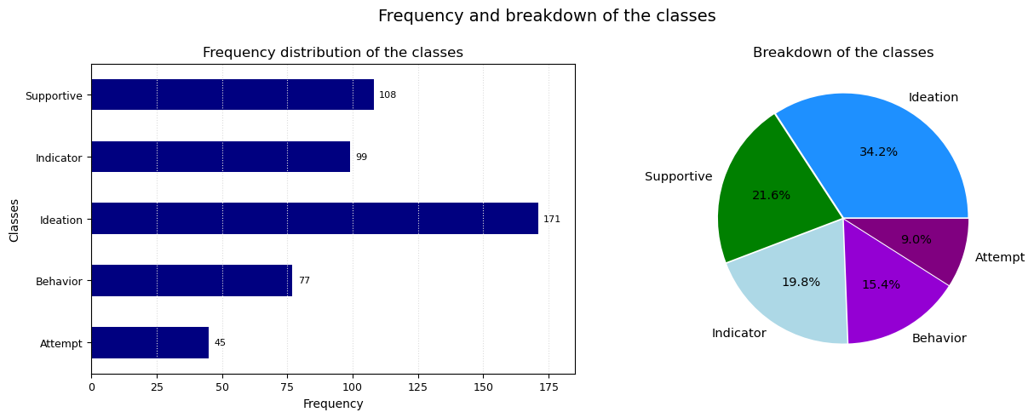

*Figure 1: Frequency and breakdown of the classes*

The dataset is quite imbalanced, with the biggest class, "Ideation", accounting for almost 35% of entries, and the smallest class, "Attempt", for less than 10%.

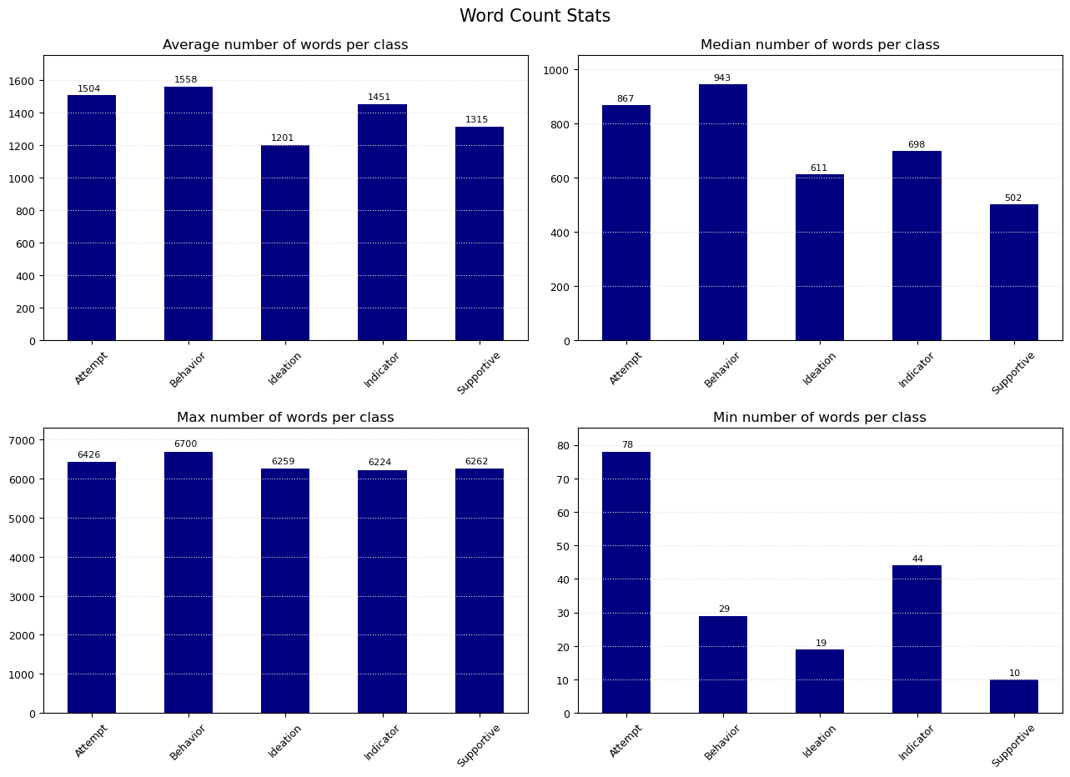

*Figure 2: Word Count Statistics*

Some considerations:

* The average number of words used by a user is around 1,200 - 1,500, depending on the class, whilst the median number of words is much lower: from 500 to 900 words, depending on the class. This means the mean number of words is skewed by few very long posts.
* The longest user's text in all classes is above 6,000 words: these are the texts that skew the mean.

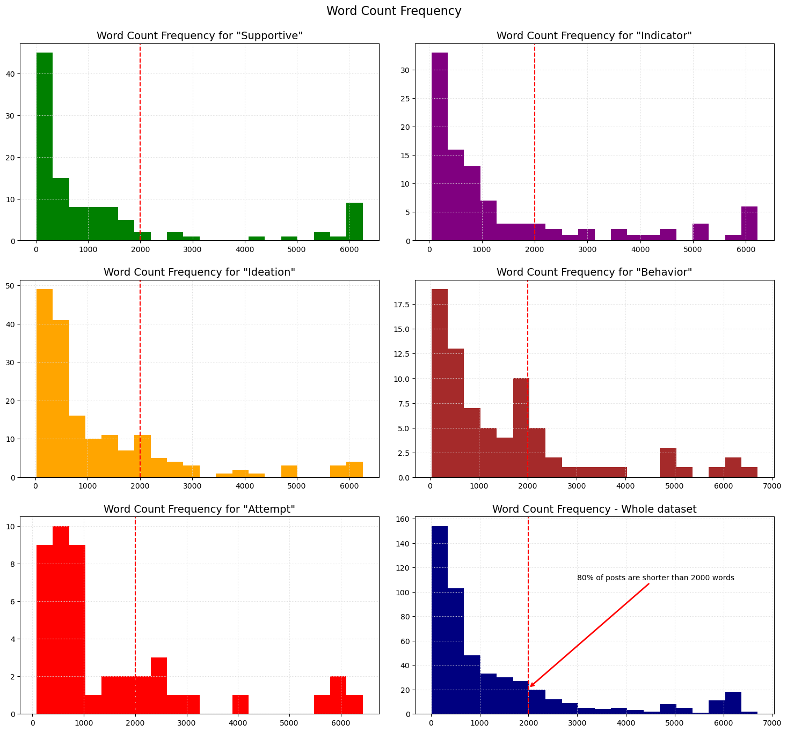

*Figure 3: Word Count Frequency per Class*

The Word Count Frequency is more or less the same in all classes (with users labelled as "Attempt" and "Behavior" that tend to write slightly longer texts then the others). **Almost 80% of the users' posts are shorter than 2,000 words.**

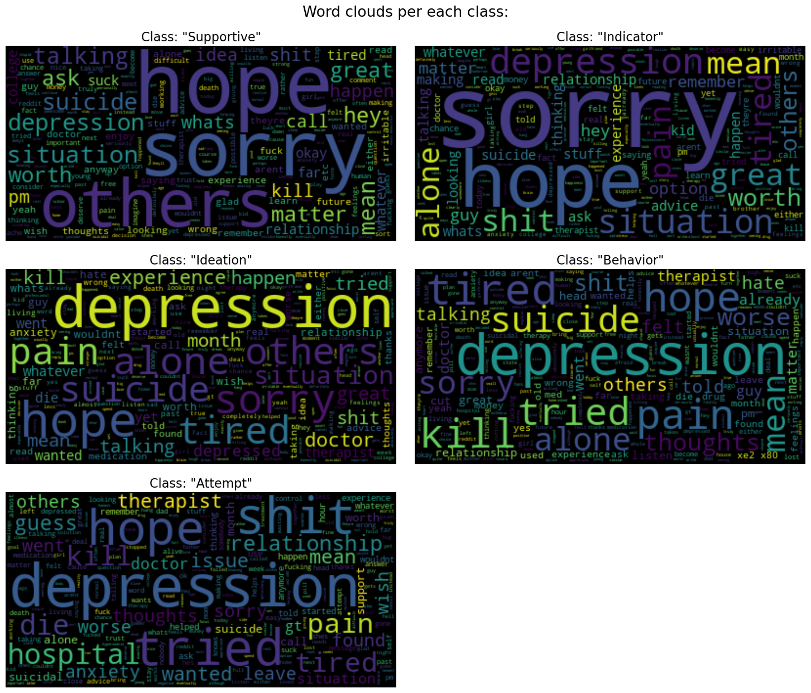

*Figure 4: Word Cloud Analysis*

Notes:

* Since 80% of users' texts are shorter than 2,000 words, word clouds were plotted up to the most frequent 2,000 words.
* The first word clouds didn’t show any type of patterns, or semantic meaning, with regard to the classes: the most common words (life, people, thing, know, want...) were, in fact, shared by all classes. Therefore, I added these "shared" words to the list of stop words, trying to show a clearer pattern, or boundary, between the classes. The word clouds included in this report, are, the result of this work of finding and removing the most common shared words.
* As a result the list pf stop words included 372 words.

Thanks to the word cloud analysis, we can have a better understanding of the classes, and start defining the boundary between users "at risk" and "not at risk":

* Words like "hope" and "sorry", although used in each class, have a greater relative frequency in the texts posted by the users labelled as "Supportive" and "Indicator".
* The word "depression", although widely used in all labels, is very frequent in the texts posted by the users labelled as "Ideation", "Behavior", and "Attempt", alongside with words such as "alone", "pain", "kill", "suicide", "hospital", "tired"...

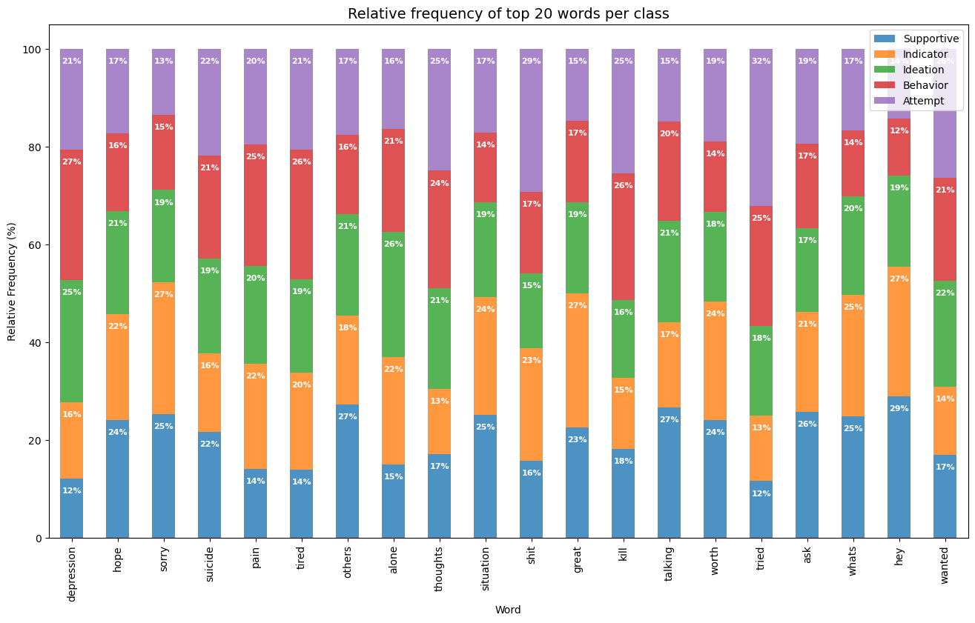

*Figure 5:* *Top 20 words - Relative Frequency Analysis*

Top 20 words - Relative Frequency Analysis results:

* Users labelled as **Supportive** and **Indicator** use, more often than the others, words such as "sorry", and "worth"; this suggests that post authors may express sympathy for someone else's problem or life situation.
* The same users also use (more often than the others) non-meaningful words such as "great", "whats", and "hey". Although these words don't carry any meaning per se (or anyway not outside the context), this difference may indicate a tendency of these users to use "lighter" words, and an overall tone of voice more friendly, easy-going, and casual.
* Users labelled as **Ideation, Behavior**, and **Attempt** use, more often than the others, words such as "depression", "thoughts", "tried", and "wanted". This suggests an ongoing struggle with mental issues like depression, a failed attempt at something (maybe suicide, or maybe a life goal), and a general feeling of regret.

**Exploratory Data Analysis results:**

* **Supportive** and **Indicator**: these users don't seem to suffer from mental issues (or anyway not in a severe way) and they are not at risk of attempting suicide or self-harm. **I classify these users as Not-at-risk (Negative Class)**.
* **Ideation, Behavior, Attempt**: these users struggle with depression, or other mental issues, they may be having suicidal thoughts, dealing with suicidal behavior, have already tried to commit suicide, or actively planning to do it. **These are the users at-risk of attempting suicide or self-harm (Positive Class)**.

**2.3. Model Development**

Models have been built, evaluated, and compared following the below methodology:

* Created a Pipeline with MinMaxScaler and the classification model.
* Fitted the model on the training set, using GridSearchCV method to find the best hyperparameters with stratified Cross Validation technique (5 stratified shuffled splits).
* Set GridSearchCV scoring argument to F-1 score, **to select the best model with the greatest harmonic mean of precision and recall of the positive class**: considering the greatly imbalanced distribution of the target variable, using accuracy score as GridSearchCV scoring argument might have led to select as best model a classifier not really able to predict examples belonging to the minority class (the positive one).
* Make predictions using the test set, and compute the following out-of-sample metrics: Confusion Matrix, Precision, Recall, F1 Score, Receiver Operating Characteristic and Precision/Recall curves, and Area Under the Curve scores.
* Whereas the classifier had probabilistic outcomes, I moved the probability threshold, and calculated the best trade-off between the Sensitivity (True Positive Rate) of positive class and the False Positive Rate, and Precision and Recall, using the following metrics:
  + Youden’s J statistic: True Positive Rate – False Positive Rate;
  + F1 Score: harmonic mean between Precision and Recall;
  + Selected the decision threshold with the **greatest macro-averaged F1-score** (the macro average doesn’t take into account the class weights, so the model with highest macro-averaged F1-score is the classifier with the best trade-off between negative and positive class predictions).
* If classifiers didn’t have the parameter “class_weight”, to deal with imbalanced classes, I applied some resampling approaches and compared the model performance, again moving the decision thresholds to find out the best predictive model. The tested resampling approaches were:
  + Undersampling the majority class with **Edited Nearest Neighbors**
  + Oversampling the minority class with **SMOTE (Synthetic Minority Oversampling Technique) algorithm**
  + Resampling the whole dataset combining **Edited Nearest Neighbors and SMOTE.**
* If the models had the parameter “class_weight” to deal with imbalanced classes, I included that parameter as hyperparameter to be tested using GridSearchCV; tested options for “class_weight” were:
  + original weights
  + balanced weights: automatically adjust weights inversely proportional to class frequencies
  + balanced subsample: the balanced weights are computed based on the bootstrap sample for every tree
  + customized weights: 80% vs 20%, and 70% vs 30% (negative vs positive class).
    1. **Classifier 1: K-Nearest Neighbors (KNN).**

KNN best hyperparameters, found with GridSearchCV (5 stratified shuffled splits) fitted on the train set:

* Number of Neighbors (K): 9.
* Type of Distance: Manhattan Distance (L1).
* Weights of Neighbors: uniform (all points in each neighborhood are weighted equally).

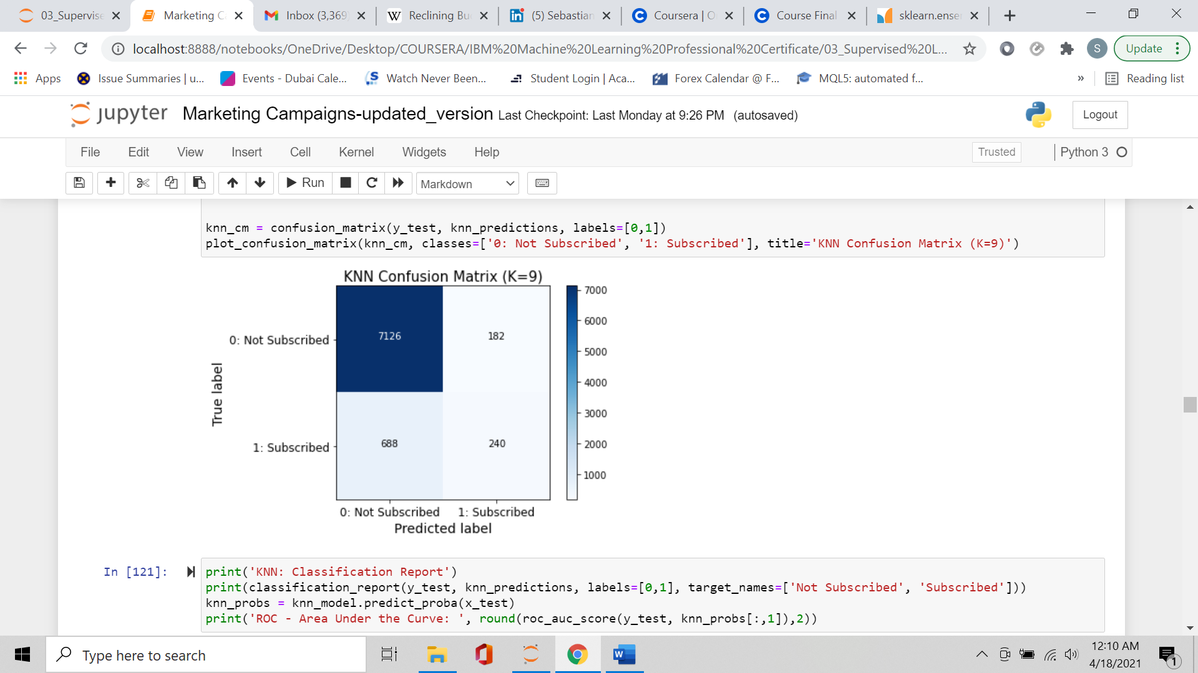Confusion Matrix and Classification Report:

KNN: Classification Report

precision recall f1-score support

Not Subscribed 0.91 0.98 0.94 7308

Subscribed 0.57 0.26 0.36 928

accuracy 0.89 8236

macro avg 0.74 0.62 0.65 8236

weighted avg 0.87 0.89 0.88 8236

ROC - Area Under the Curve: 0.75

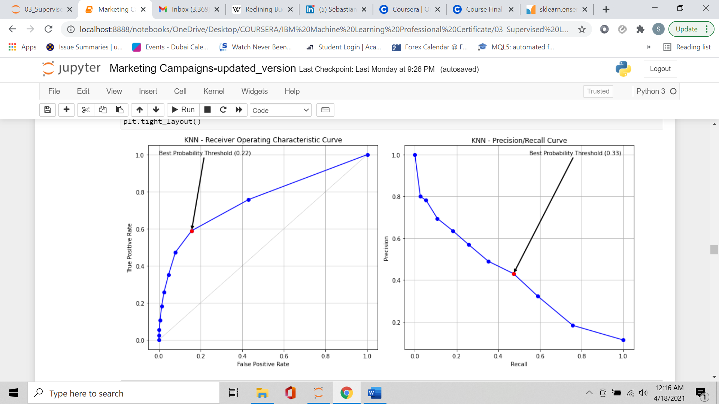ROC and Precision/Recall curves, with the best decision threshold:

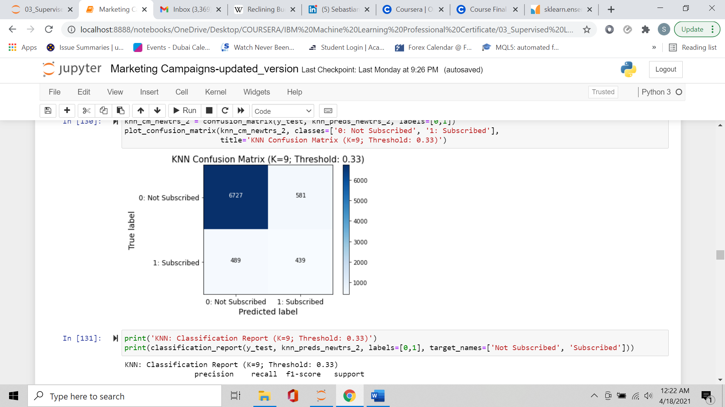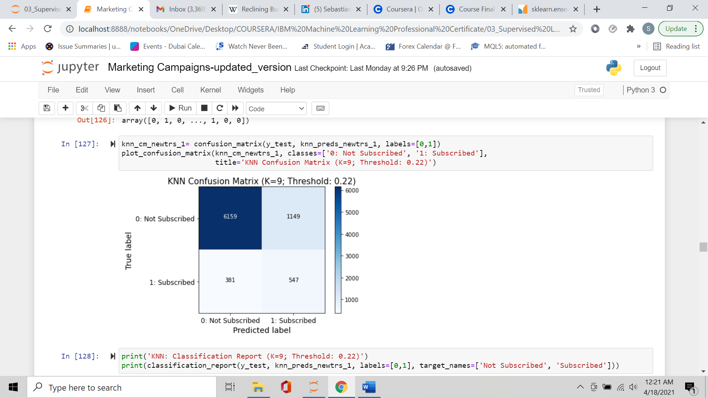Confusion Matrix and Classification Report - best decision thresholds:

KNN: Classification Report (K=9; Threshold: 0.22)

precision recall f1-score support

Not Subscribed 0.94 0.84 0.89 7308

Subscribed 0.32 0.59 0.42 928

accuracy 0.81 8236

macro avg 0.63 0.72 0.65 8236

weighted avg 0.87 0.81 0.84 8236

KNN: Classification Report (K=9; Threshold: 0.33)

precision recall f1-score support

Not Subscribed 0.93 0.92 0.93 7308

Subscribed 0.43 0.47 0.45 928

accuracy 0.87 8236

macro avg 0.68 0.70 0.69 8236

weighted avg 0.88 0.87 0.87 8236

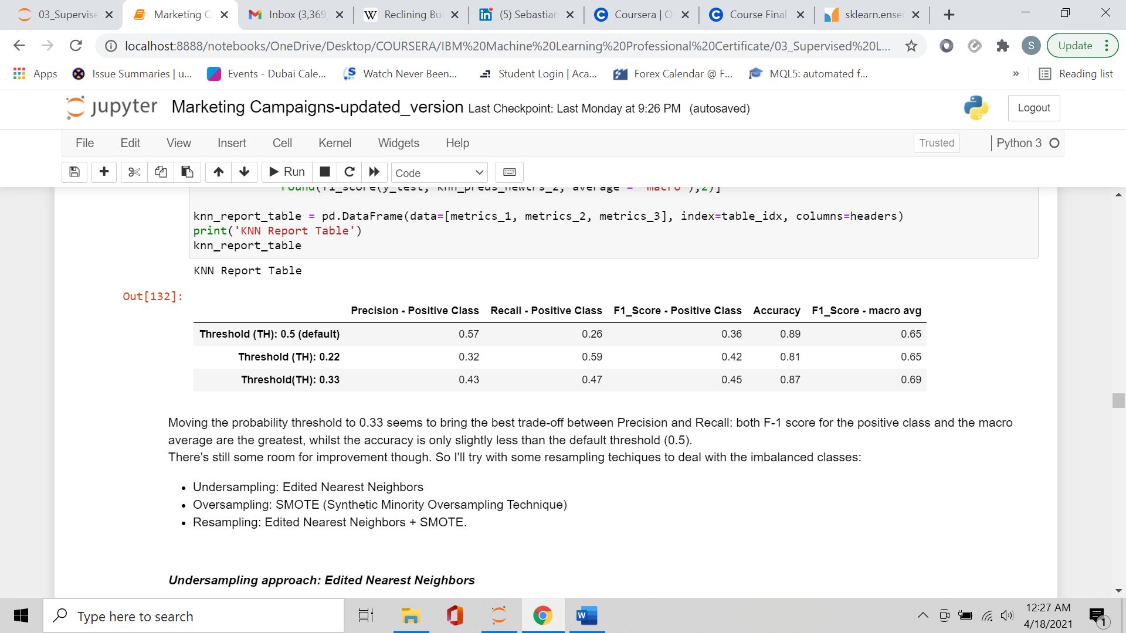

Probability threshold at 0.33 was the threshold with the best trade-off between Precision and Recall: both positive class and macro-averaged F-1 scores were the greatest, whilst the accuracy was only slightly less than the default threshold (0.5).

KNN algorithm doesn’t have the parameter “class_weight”, therefore I tested the model applying the following resampling approaches:

* Undersampling: Edited Nearest Neighbors
* Oversampling: SMOTE (Synthetic Minority Oversampling Technique)
* Resampling: Edited Nearest Neighbors + SMOTE.

**Undersampling approach: Edited Nearest Neighbors**

Edited Nearest Neighbors locates the majority-class points that are missclassified (using K-Nearest Neighbors algorithm), and drops them. Edited Nearest Neighbors works as follows:

* Pick an example and compute its K nearest neighbors.
* If the example is a majority class instance and is misclassified by its K nearest neighbors, then it is removed from the dataset.
* If the example is a minority class instance and is misclassified by its K nearest neighbors, then the majority class instances among the neighbors are removed.

Edited Nearest Neighbors removes majority-class points that are ambiguous and noisy (that is majority-class points too close to minority-class points), thus creating more distinct classes.

Edited Nearest Neighbors algorithm has some hyperparameters to be tuned: the number of neighbors (k), and the strategy to use in order to exclude samples (kind_sel: "all" (all neighbours will have to agree with the samples of interest to not be misclassified), or "mode" (majority vote of the neighbours of the samples of interest to not be misclassified). Therefore, I followed the below methodology:

* Created a Pipeline object with MinMax Scaler, Edited Nearest Neighbors (ENN), and KNN Classifier.
* Fitted the pipeline on the training set, using GridSearchCV method to find the best hyperparameters for ENN algorithm, and KNN model, and the same cross-validation approach (5 stratified shuffled splits).
* Make predictions using the test set, and compute the relevant out-of-sample metrics.

The optimum hyperparameters were:

* Edited Nearest Neighbours:
  + kind_sel: "all" -> All neighbors have to agree with the samples of interest to not be misclassified.
  + Number of neighbors: 6.
* KNN Classifier:
  + Number of Neighbors (K): 37.
  + Type of Distance: Manhattan Distance (L1).
  + Weights of Neighbors: uniform (all neighbors have same weight).

ENN algorithm reduced the number of observations as follows:

Number of observations before undersampling: 32,940

Number of observations after undersampling: 23,637

Number of removed observations (majority class): 9,303

Confusion Matrix and Classification Report:

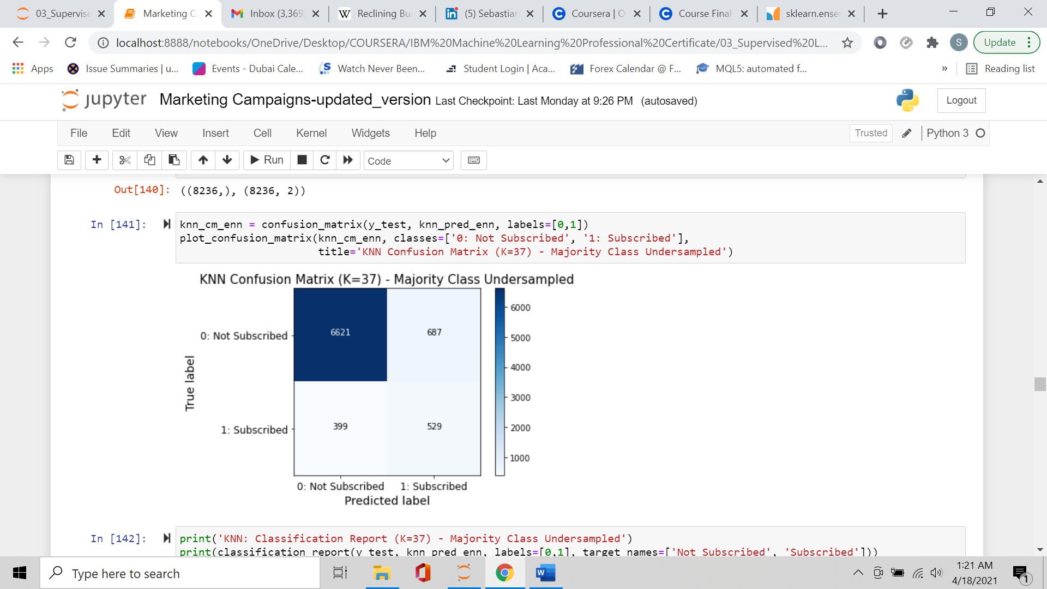

KNN: Classification Report (K=37) - Majority Class Undersampled

precision recall f1-score support

Not Subscribed 0.94 0.91 0.92 7308

Subscribed 0.44 0.57 0.49 928

accuracy 0.87 8236

macro avg 0.69 0.74 0.71 8236

weighted avg 0.89 0.87 0.88 8236

ROC Area Under the Curve - Original DS: 0.75

ROC Area Under the Curve - Undersampled DS: 0.77

Precision/Recall Area Under the Curve - Original DS: 0.41

Precision/Recall Area Under the Curve - Undersampled DS: 0.45

Undersampling the majority class increased the model F1-Score from 0.69 to 0.71 (macro

average), the Area Under the Curves, and all metrics related to the Positive Class.

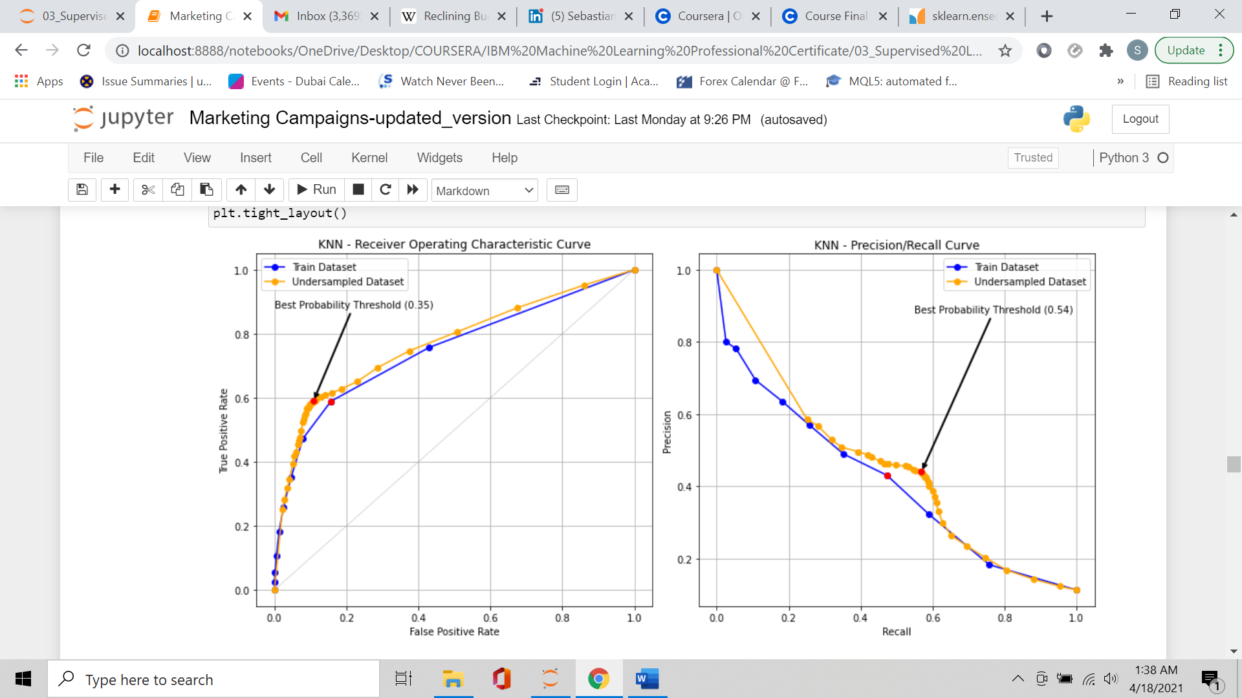ROC and Precision/Recall curves with best decision threshold:

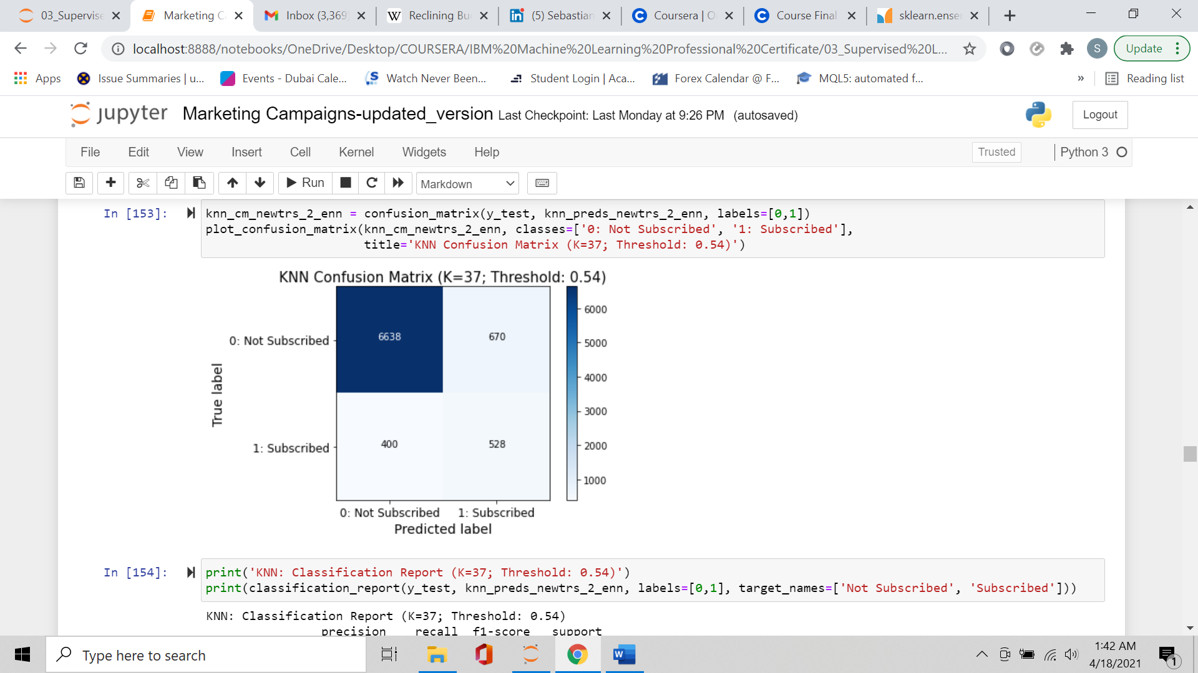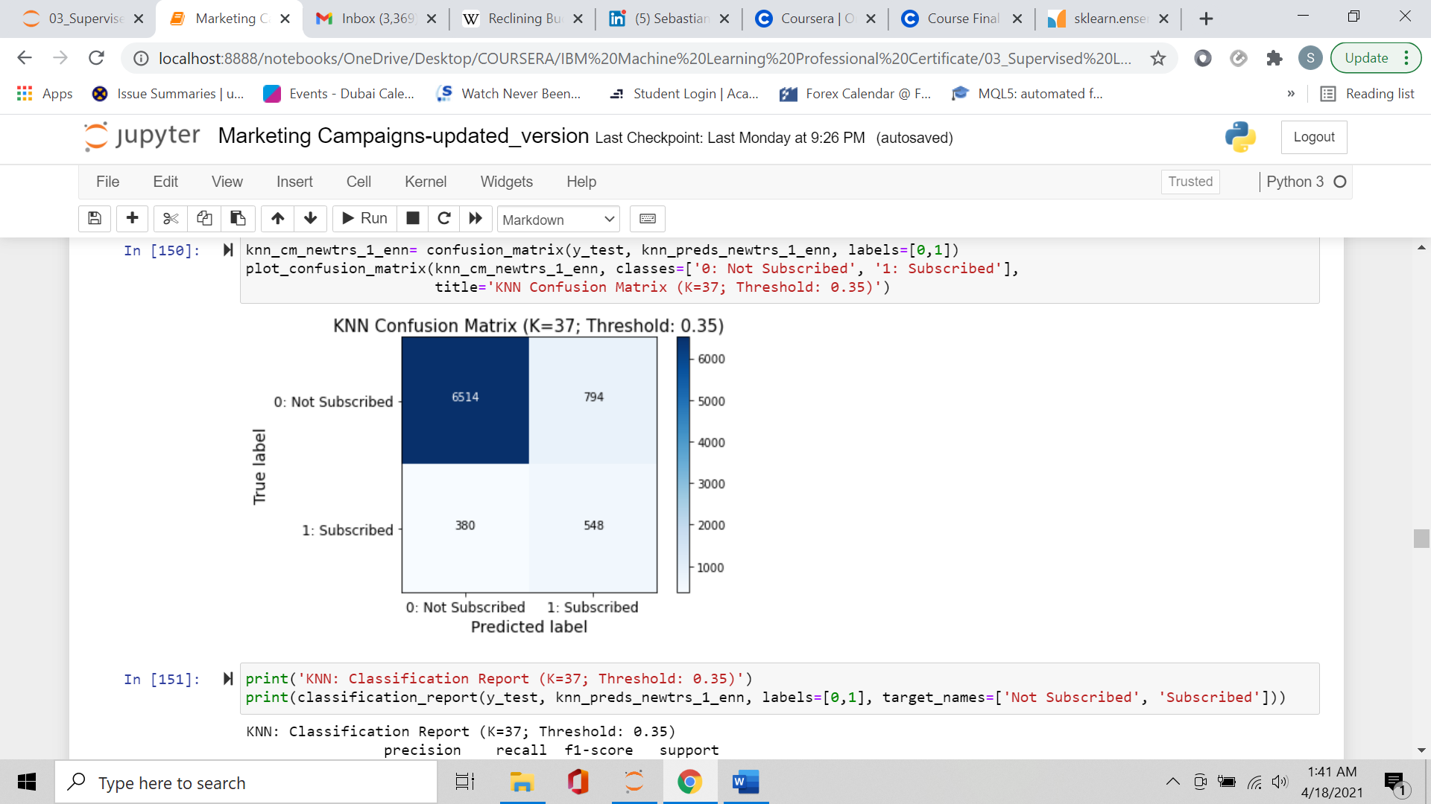Confusion Matrix and Classification Report - best decision thresholds:

KNN: Classification Report (K=37; Threshold: 0.35)

precision recall f1-score support

Not Subscribed 0.94 0.89 0.92 7308

Subscribed 0.41 0.59 0.48 928

accuracy 0.86 8236

macro avg 0.68 0.74 0.70 8236

weighted avg 0.88 0.86 0.87 8236

KNN: Classification Report (K=37; Threshold: 0.54)

precision recall f1-score support

Not Subscribed 0.94 0.91 0.93 7308

Subscribed 0.44 0.57 0.50 928

accuracy 0.87 8236

macro avg 0.69 0.74 0.71 8236

weighted avg 0.89 0.87 0.88 8236

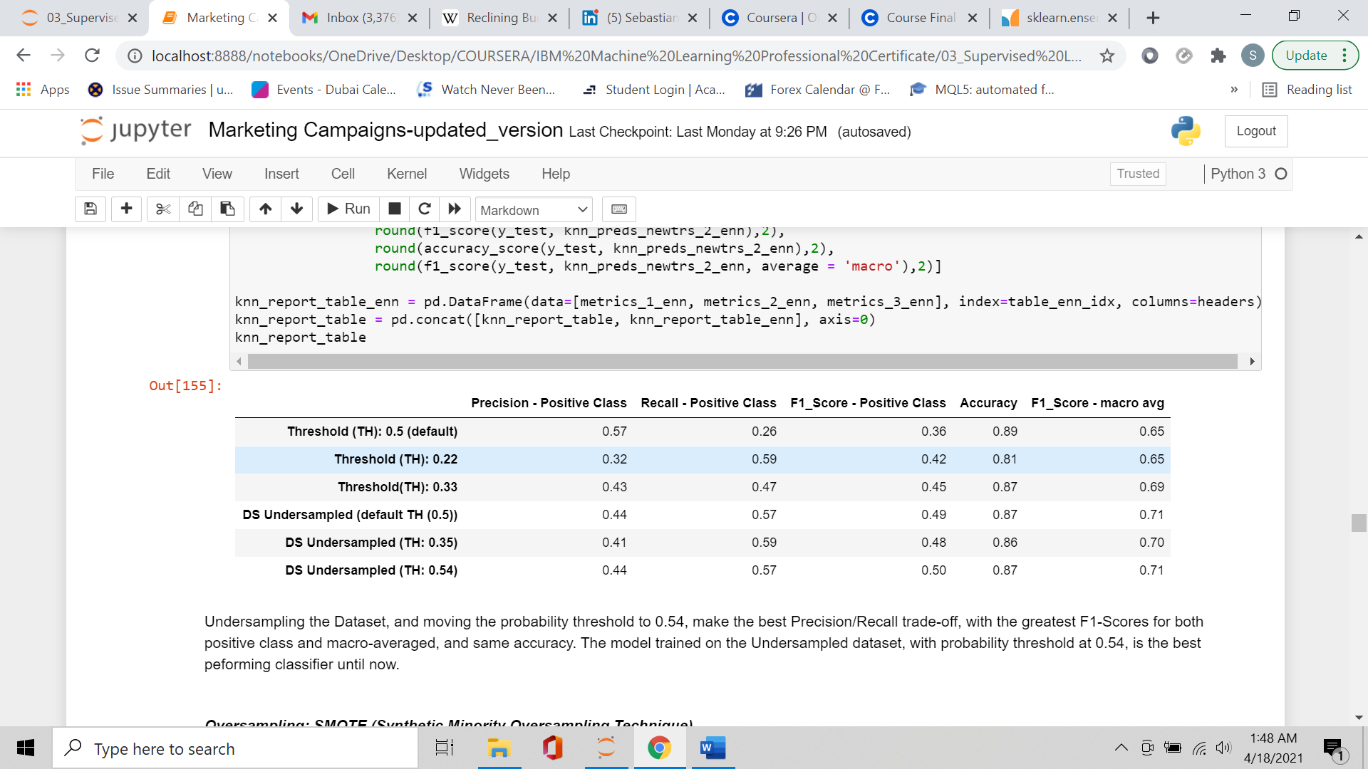

Undersampling the Dataset, and moving the probability threshold to 0.54, made the best classifier, with the greatest positive class and macro-averaged F1-Scores, without significantly losing accuracy.

**Oversampling: SMOTE (Synthetic Minority Oversampling Technique)**

SMOTE (Synthetic Minority Oversampling Technique) is a technique that generates new samples by interpolation. Considering the mixed types of data in the dataset (continuous, discrete and categorical), I used SMOTENC, that is an extension of SMOTE algorithm able to deal with categorical data (SMOTE algorithm automatically takes care of discrete features).

SMOTENC creates synthetic samples of the minority class, by creating new samples between the minority points and their k neighbors for continuous/discrete features (regular SMOTE), and by resampling the categorical features.

Best hyperparameters:

* Number of Neighbors (K): 71.
* Type of Distance: Manhattan Distance (L1).
* Weights of Neighbors: Distance (samples are weighted by the inverse of their distance: closer neighbors have a greater influence).

SMOTENC algorithm balanced the classes, and increased the number of observations as follows:

Number of observations before oversampling: 32,940

Number of observations after oversampling: 58,458

Number of synthetic samples (minority class): 25,518

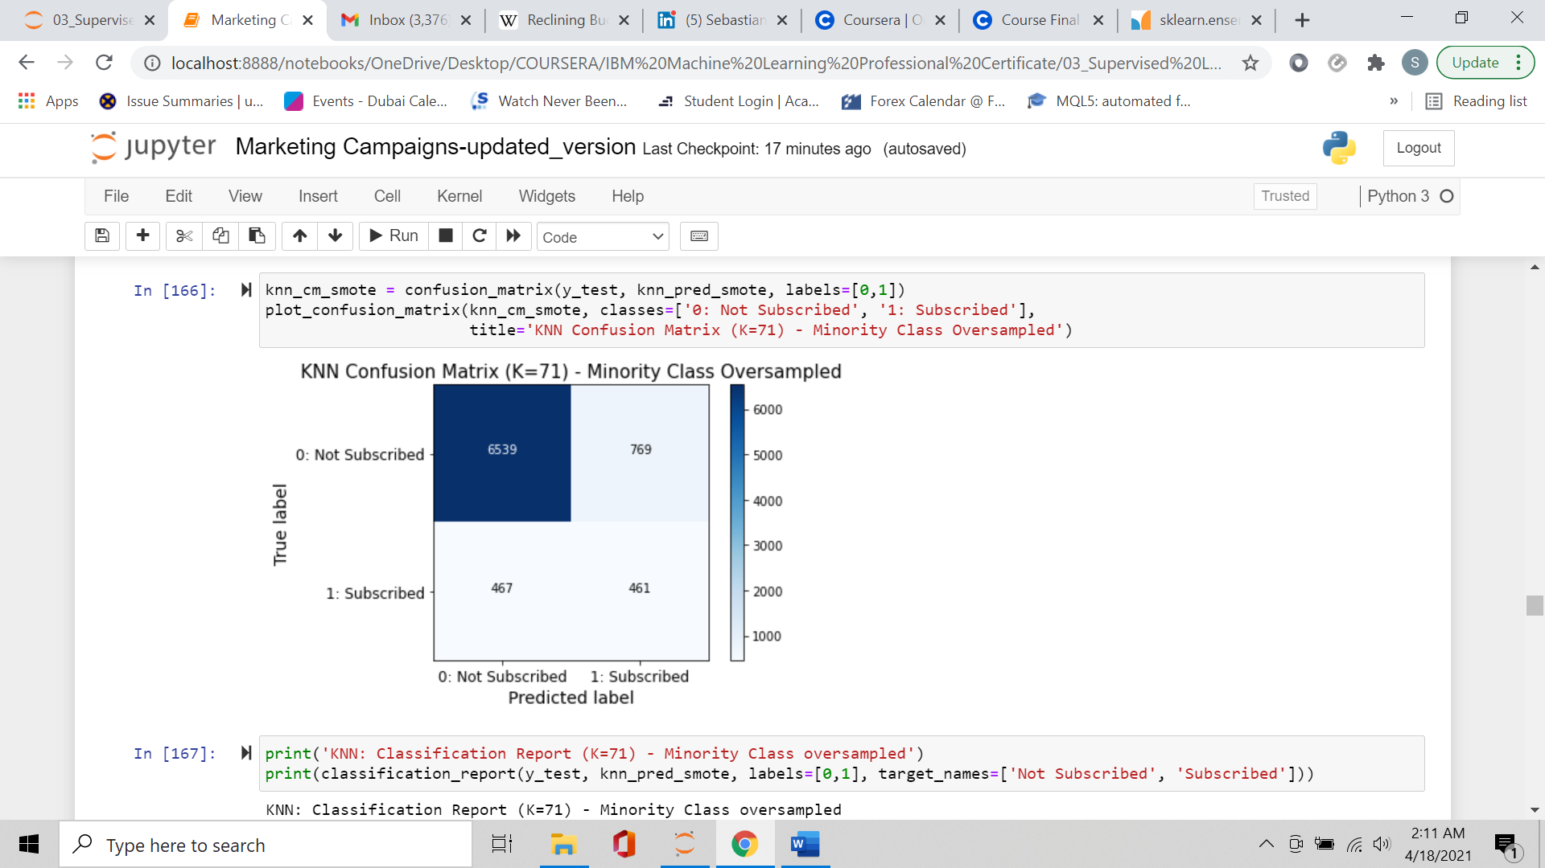

KNN: Classification Report (K=71) - Minority Class oversampled

precision recall f1-score support

Not Subscribed 0.93 0.89 0.91 7308

Subscribed 0.37 0.50 0.43 928

accuracy 0.85 8236

macro avg 0.65 0.70 0.67 8236

weighted avg 0.87 0.85 0.86 8236

ROC Area Under the Curve - Original DS: 0.75

ROC Area Under the Curve - Undersampled DS: 0.77

ROC Area Under the Curve - Oversampled DS: 0.71

Precision/Recall Area Under the Curve - Original DS: 0.41

Precision/Recall Area Under the Curve - Undersampled DS: 0.45

Precision/Recall Area Under the Curve - Oversampled DS: 0.34

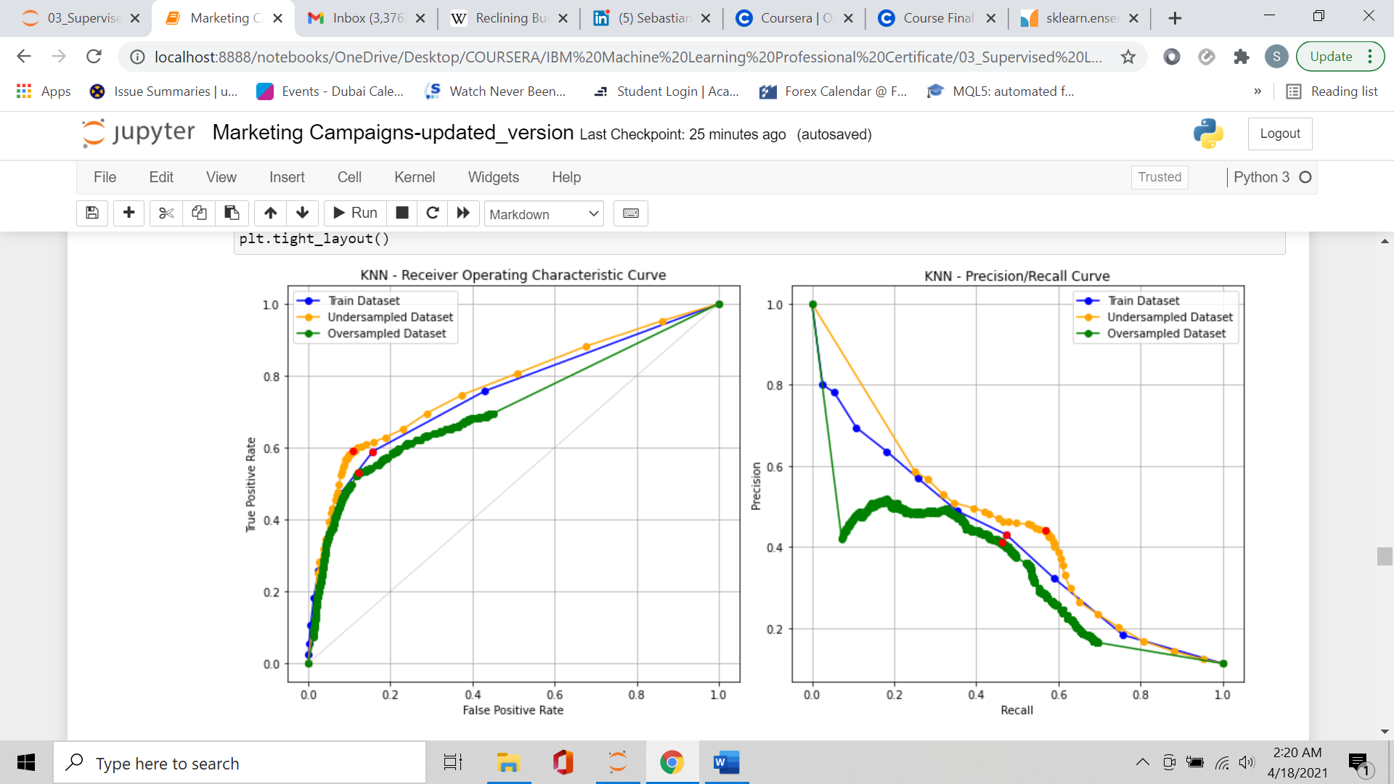ROC and Precision/Recall curves, with the best decision thresholds:

Oversampling the minority class didn't make a better classifier: all relevant metrics were less than the up-to-now-best-classifier (undersampled DS with threshold at 0.54).

**Resampling : ENN + SMOTE**

I wanted to try a last sampling technique: Resampling, that is combining undersampling (Edited Nearest Neighbours) with oversampling (SMOTE). Oversampling with SMOTE didn't produce better results compared to undersampling, so I downsampled with ENN, and added on top of that SMOTE oversampling , using a different minority-to-majority ratio instead of the default one (0.2 instead of 0.5).

Best hyperparameters:

* Number of Neighbors (K): 37.
* Type of Distance: Manhatthan Distance (L1).
* Weights of Neighbors: Uniform

Resampling changed the number of observations as follows:

Number of observations before resampling: 32940

Number of removed observations: 9303

Number of synthetic samples (minority class): 274

Number of observations after resampling: 23911

Original dataset and resampled dataset delta: 9029

Confusion Matrix and Classification Report:

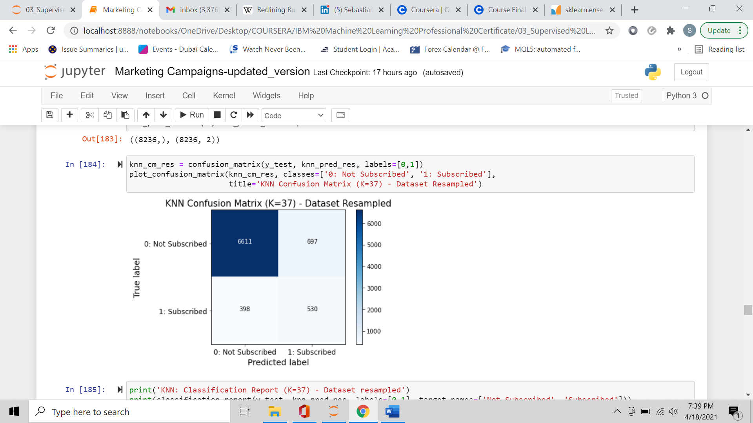

KNN: Classification Report (K=37) - Dataset resampled

precision recall f1-score support

Not Subscribed 0.94 0.90 0.92 7308

Subscribed 0.43 0.57 0.49 928

accuracy 0.87 8236

macro avg 0.69 0.74 0.71 8236

weighted avg 0.89 0.87 0.87 8236

ROC Area Under the Curve - Original DS: 0.75

ROC Area Under the Curve - Undersampled DS: 0.77

ROC Area Under the Curve - Oversampled DS: 0.71

ROC Area Under the Curve - Resampled DS: 0.77

Precision/Recall Area Under the Curve - Original DS: 0.41

Precision/Recall Area Under the Curve - Undersampled DS: 0.45

Precision/Recall Area Under the Curve - Oversampled DS: 0.34

Precision/Recall Area Under the Curve - Resampled DS: 0.45

ROC and Precision/Recall curves with best decision threshold:

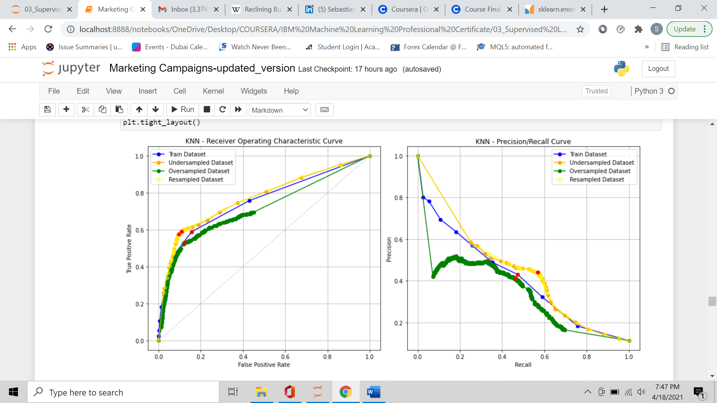

Resampling the dataset made approximately the same performance as Undersampling, with

the best probability thresholds of the 2 models very close to each other.

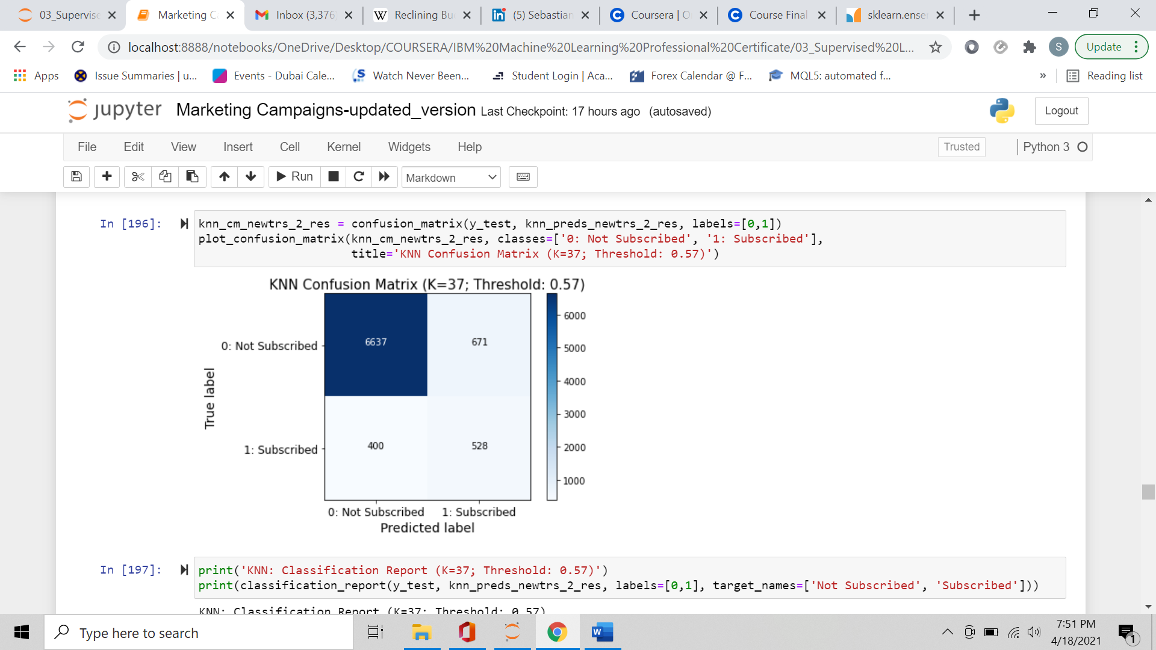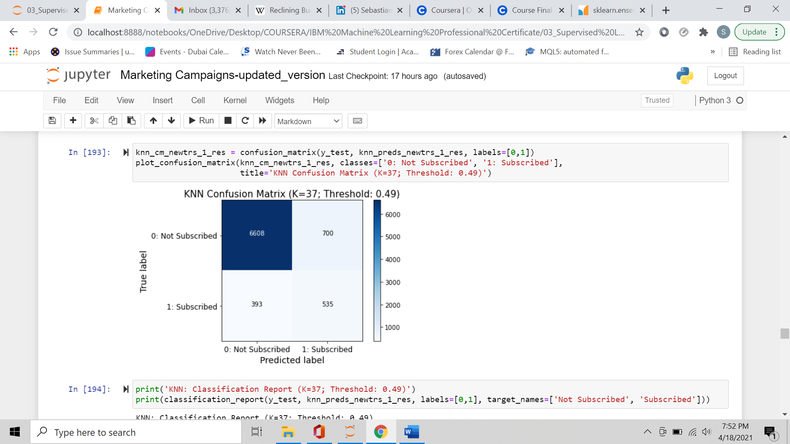Confusion Matrix and Classification Report - best decision thresholds, Resampled dataset:

KNN: Classification Report (K=37; Threshold: 0.49)

precision recall f1-score support

Not Subscribed 0.94 0.90 0.92 7308

Subscribed 0.43 0.58 0.49 928

accuracy 0.87 8236

macro avg 0.69 0.74 0.71 8236

weighted avg 0.89 0.87 0.88 8236

KNN: Classification Report (K=37; Threshold: 0.57)

precision recall f1-score support

Not Subscribed 0.94 0.91 0.93 7308

Subscribed 0.44 0.57 0.50 928

accuracy 0.87 8236

macro avg 0.69 0.74 0.71 8236

weighted avg 0.89 0.87 0.88 8236

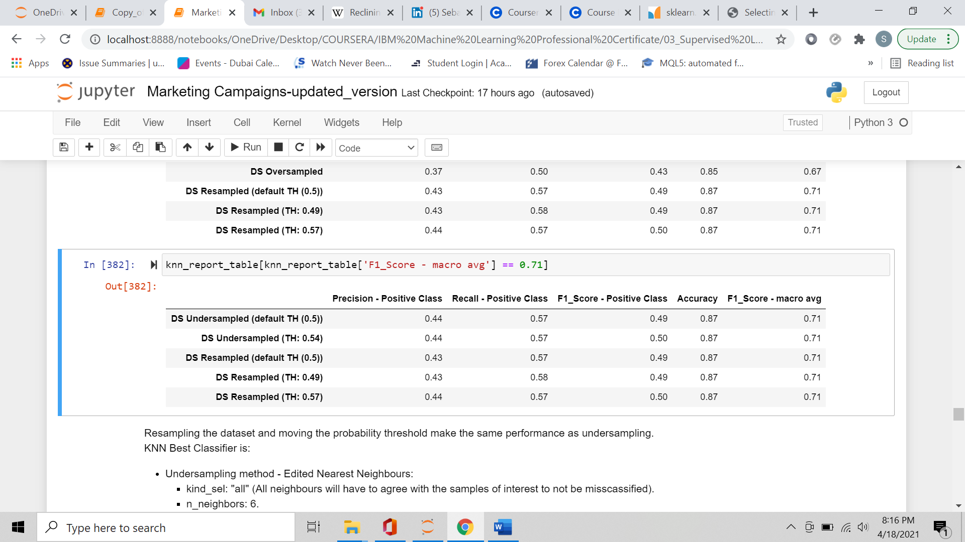Report table – models with greatest macro-averaged F1-score:

KNN Best Classifier:

* Undersampling method - Edited Nearest Neighbors:
  + kind_sel: "all" (all neighbors will have to agree with the samples of interest to

not be misscassified).

* + n_neighbors: 6.
* KNN Classifier:
  + Number of Neighbors (K): 37.
  + Type of Distance: Manhatthan Distance (L1).
  + Weights of Neighbors: uniform (all neighbors have same weight).
  + Probability Threshold: 0.54
    1. **Classifier 2: Random Forest.**

Random Forest is a non-parametric model, therefore there’s no need to make any assumptions on the data distribution, and data don't need any pre-processing transformations, like scaling.

I followed the same methodology as per the KNN model:

* Fitted the model on the training set, using GridSearchCV to find the best hyperparameters with stratified Cross Validation technique (5 stratified shuffled splits).
  + Calculated out-of-sample metrics using the test set to make predictions (confusion matrix, precision, recall, F1, Receiver Operating Characteristic Curve, precision/recall curve, and Area Under the Curves).

Best Random Forest hyperparameters:

* Class weight: balanced (automatically adjust weights inversely proportional to class frequencies).
* Criterion to compute the information gain: Gini.
* Max depth of decision trees: 5.
* Number of trees: 10.

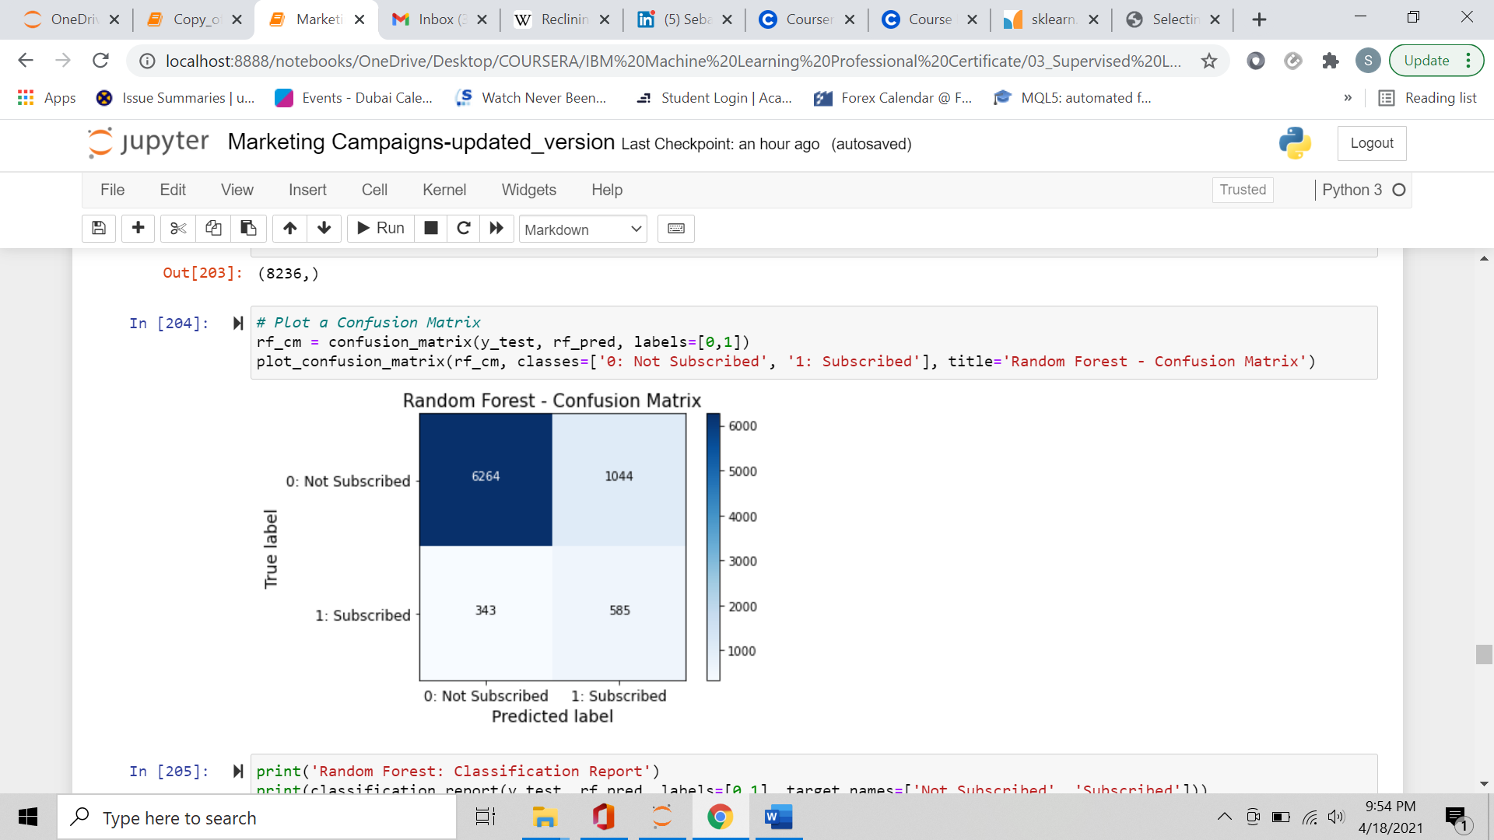Confusion Matrix and Classification Report:

Random Forest: Classification Report

precision recall f1-score support

Not Subscribed 0.95 0.86 0.90 7308

Subscribed 0.36 0.63 0.46 928

accuracy 0.83 8236

macro avg 0.65 0.74 0.68 8236

weighted avg 0.88 0.83 0.85 8236

ROC Area Under the Curve - KNN Best Classifier: 0.77

ROC Area Under the Curve - Random Forest: 0.79

Precision/Recall Area Under the Curve - KNN Best Classifier: 0.41

Precision/Recall Area Under the Curve - Random Forest: 0.42

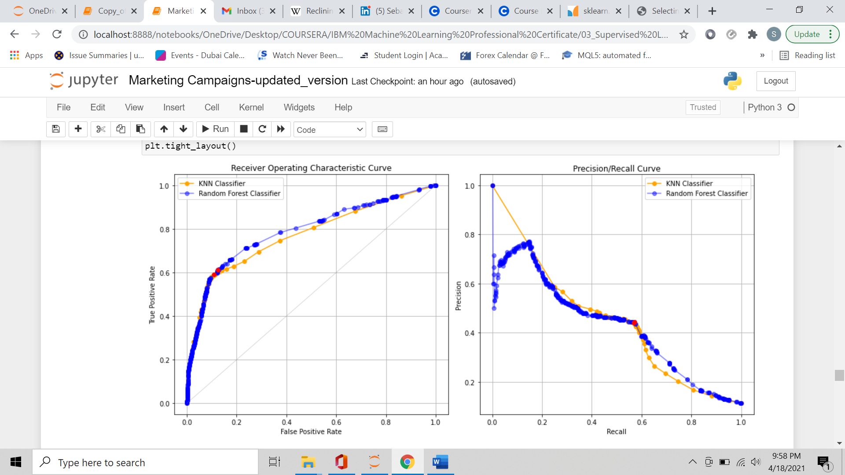

KNN and Random Forest best probability thresholds seemed to be very close to each other.

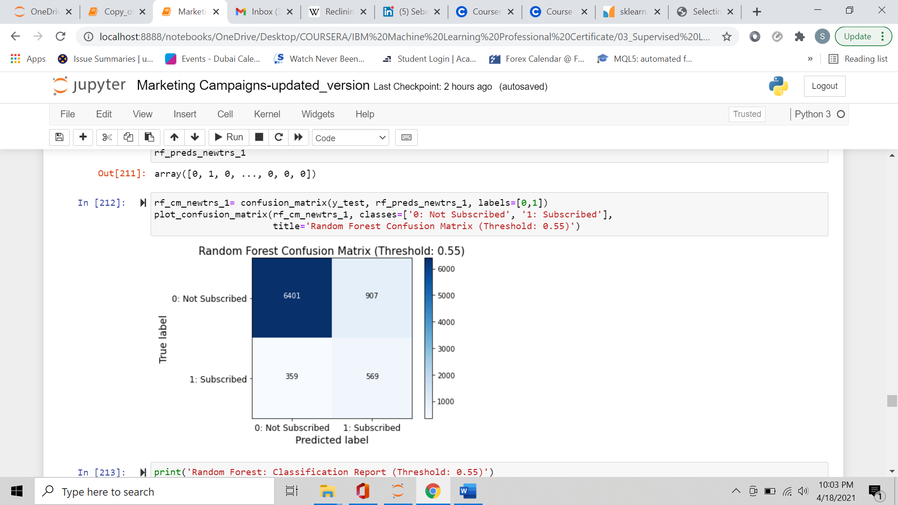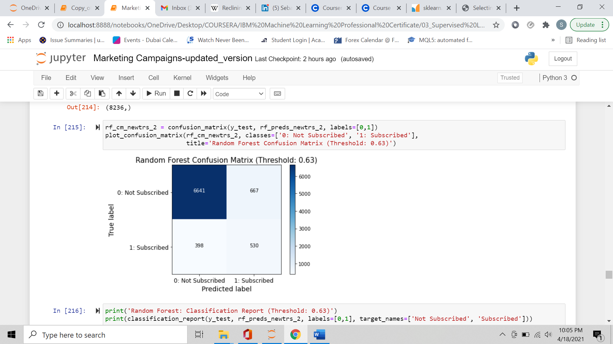Confusion Matrix and Classification Report – Random Forest best decision thresholds.

Random Forest: Classification Report (Threshold: 0.55)

precision recall f1-score support

Not Subscribed 0.95 0.88 0.91 7308

Subscribed 0.39 0.61 0.47 928

accuracy 0.85 8236

macro avg 0.67 0.74 0.69 8236

weighted avg 0.88 0.85 0.86 8236

Random Forest: Classification Report (Threshold: 0.63)

precision recall f1-score support

Not Subscribed 0.94 0.91 0.93 7308

Subscribed 0.44 0.57 0.50 928

accuracy 0.87 8236

macro avg 0.69 0.74 0.71 8236

weighted avg 0.89 0.87 0.88 8236

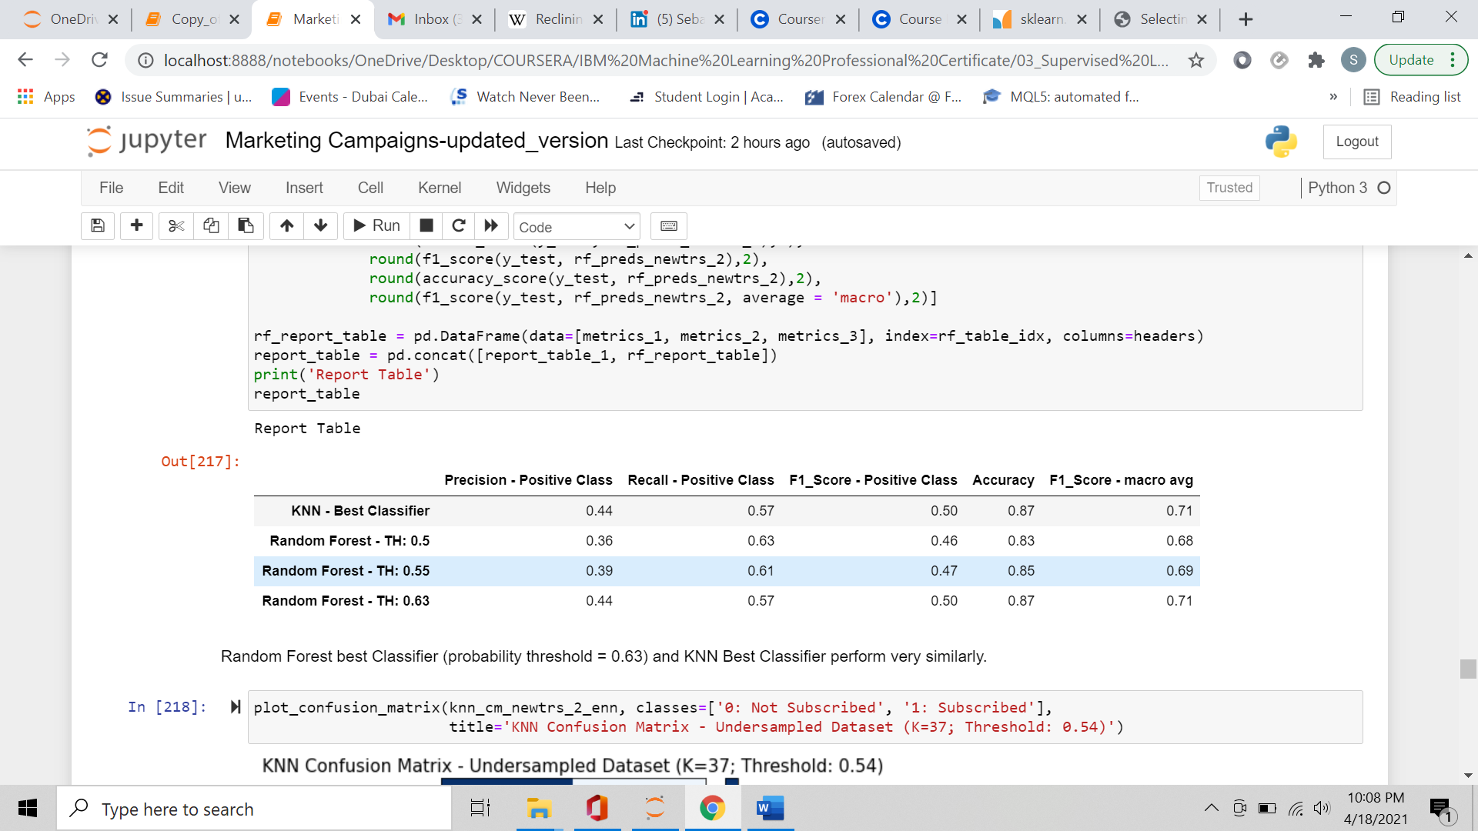

Random Forest best classifier:

* Number of estimators/trees: 10
* Criterion to measure the Information Gain: Gini
* Maximum depth of Decision Trees: 5
* Class Weight: balanced weights
* Probability Threshold: 0.63

Random Forest and KNN Best Classifiers performed very similarly.

* + 1. **Classifier 3: Support Vector Machines.**

Best Support Vector Machines hyperparameters:

* Kernel used to map data to higher dimensions: Radial Basis Function.
* Regularization Parameter: 1.
* 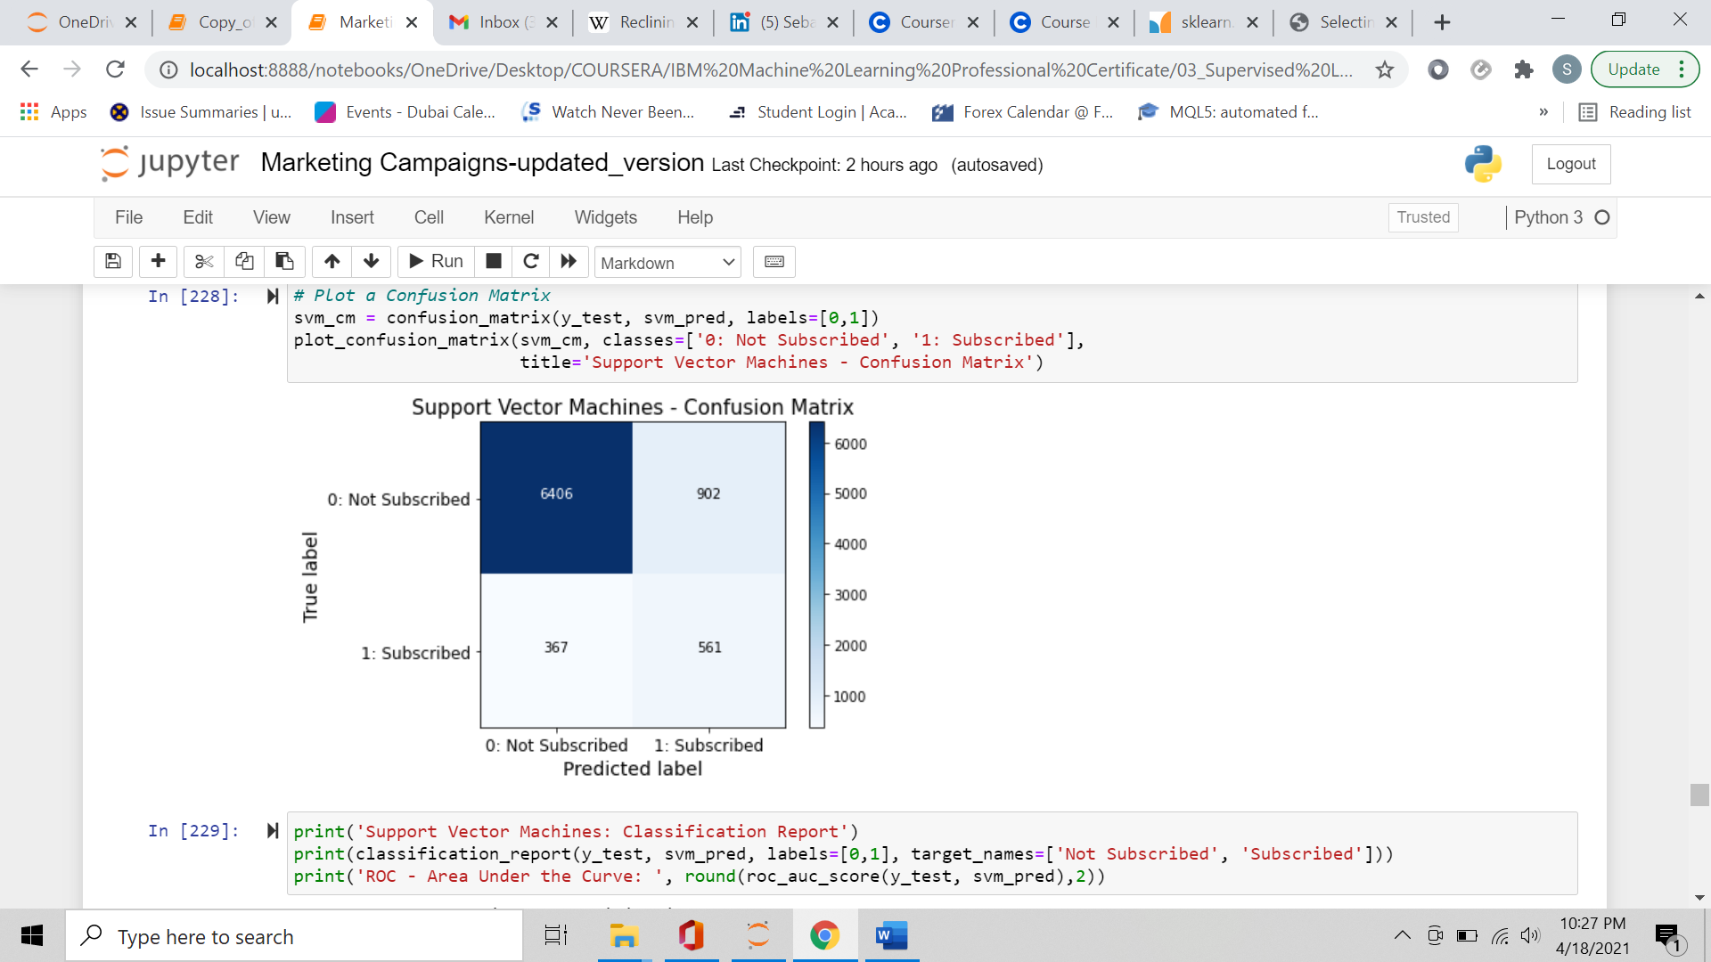Class weight: Balanced.

Support Vector Machines: Classification Report

precision recall f1-score support

Not Subscribed 0.95 0.88 0.91 7308

Subscribed 0.38 0.60 0.47 928

accuracy 0.85 8236

macro avg 0.66 0.74 0.69 8236

weighted avg 0.88 0.85 0.86 8236

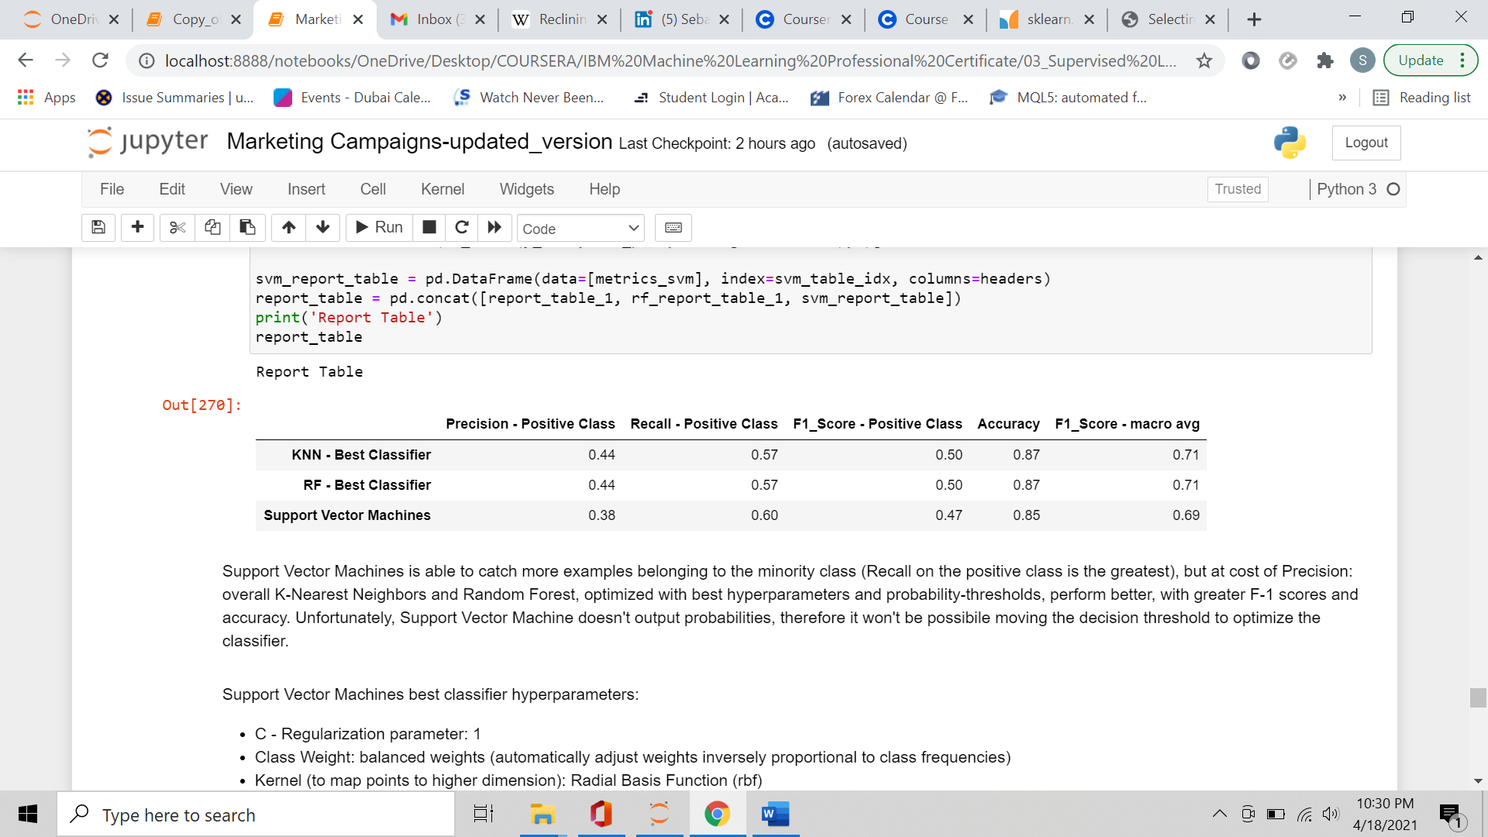Report Table:

Support Vector Machine was able to catch more examples belonging to the minority class (Recall on the positive class is the greatest), but at cost of Precision: overall K-Nearest Neighbors and Random Forest, optimized with best hyperparameters and probability-thresholds, performed better, with greater F-1 scores and accuracy.

Support Vector Machine doesn't output probabilities, therefore it wasn’t possible moving the decision threshold to optimize the classifier.

* + 1. **Classifier 4: Ensemble Model - Stacking Classifier.**

As last Classifier I wanted to stack the 3 trained model (base estimators), and train a meta-classifier (final estimator) using the outputs of the base estimators as inputs for the final estimator: this is an Ensemble Model called "Stacking".

The base estimators (KNN, Random Forest, and SVM) were trained with the (already found) best hyperparameters, and I fitted the Stacking Classifier on the training set, using GridSearchCV to test what meta-classifier and parameters worked best.

Hyperparameter grid was as follows:

* Meta-classifiers: Logistic Regression, Decision Tree
  + Hyperparameters for Logistic Regression:
    - Type of penalty for regularization: L2 penalty, no penalty
    - Regularization Parameter - C: 1.0, 0.5, 0.1
    - Class weight: original weights, balanced weights
  + Hyperparameters for Decision Tree:
    - Criterion for information gain: Gini, Entropy
    - Max depth for decision Trees: None, 2
    - Class weight: original weights, balanced weights

The final-estimator best hyperparameters are:

* Logistic Regression.
* Penalty: L2 penalty.
* C - Regularization Parameter: 0.1.
* Class weight: balanced weights.

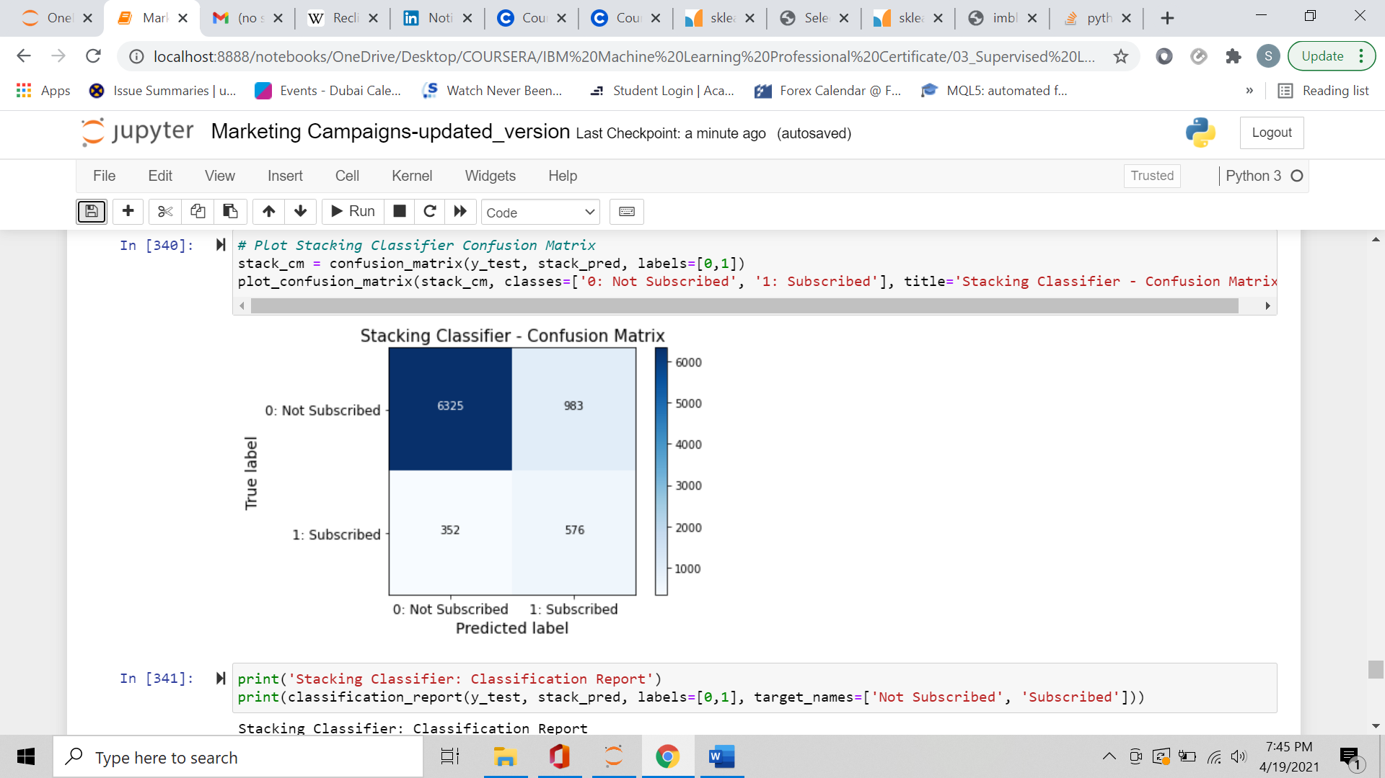Confusion Matrix and Classification Report:

Stacking Classifier: Classification Report

precision recall f1-score support

Not Subscribed 0.95 0.87 0.90 7308

Subscribed 0.37 0.62 0.46 928

accuracy 0.84 8236

macro avg 0.66 0.74 0.68 8236

weighted avg 0.88 0.84 0.85 8236

ROC Area Under the Curve - KNN Best Classifier: 0.77

ROC Area Under the Curve - Random Forest Best Classifier: 0.79

ROC Area Under the Curve - Stacking Classifier: 0.79

Precision/Recall Area Under the Curve - KNN Best Classifier: 0.41

Precision/Recall Area Under the Curve - Random Forest Best Classifier:0.42

Precision/Recall Area Under the Curve - Stacking Classifier: 0.43

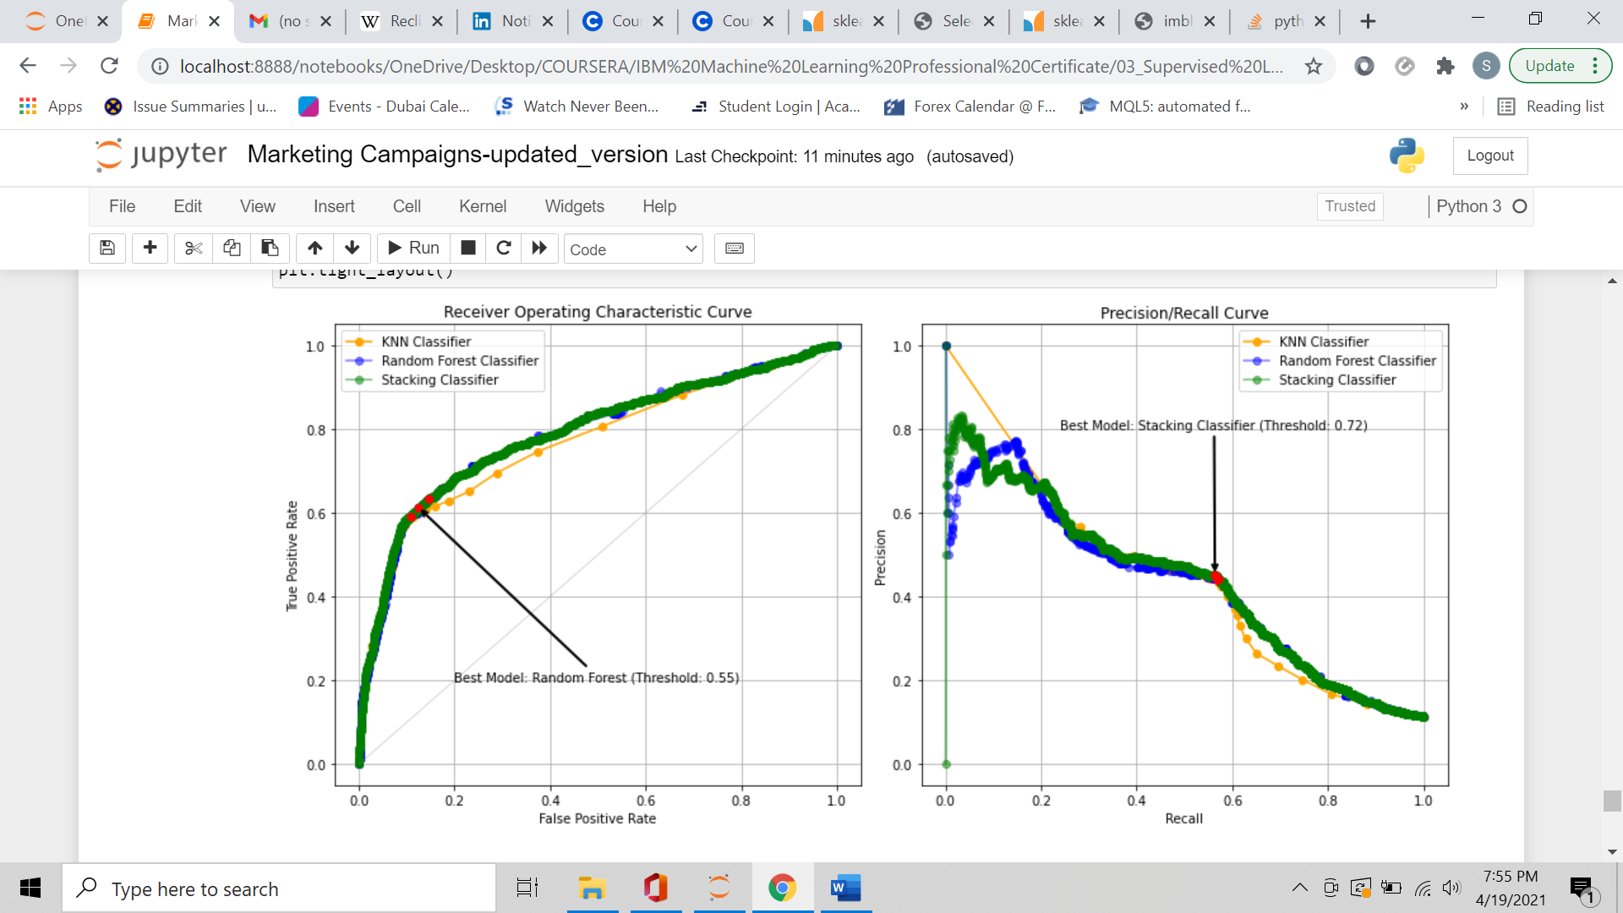ROC and Precision/Recall curves with best decision threshold:

Random Forest is the model with the greatest Youden's J statistic.

Best probability threshold: 0.5472990213846068

Stacking Classifier is the model with the greatest F1-Score.

Best probability threshold: 0.7153119838862827

Confusion Matrix and Classification Report for Stacking Classifier - best probability threshold:

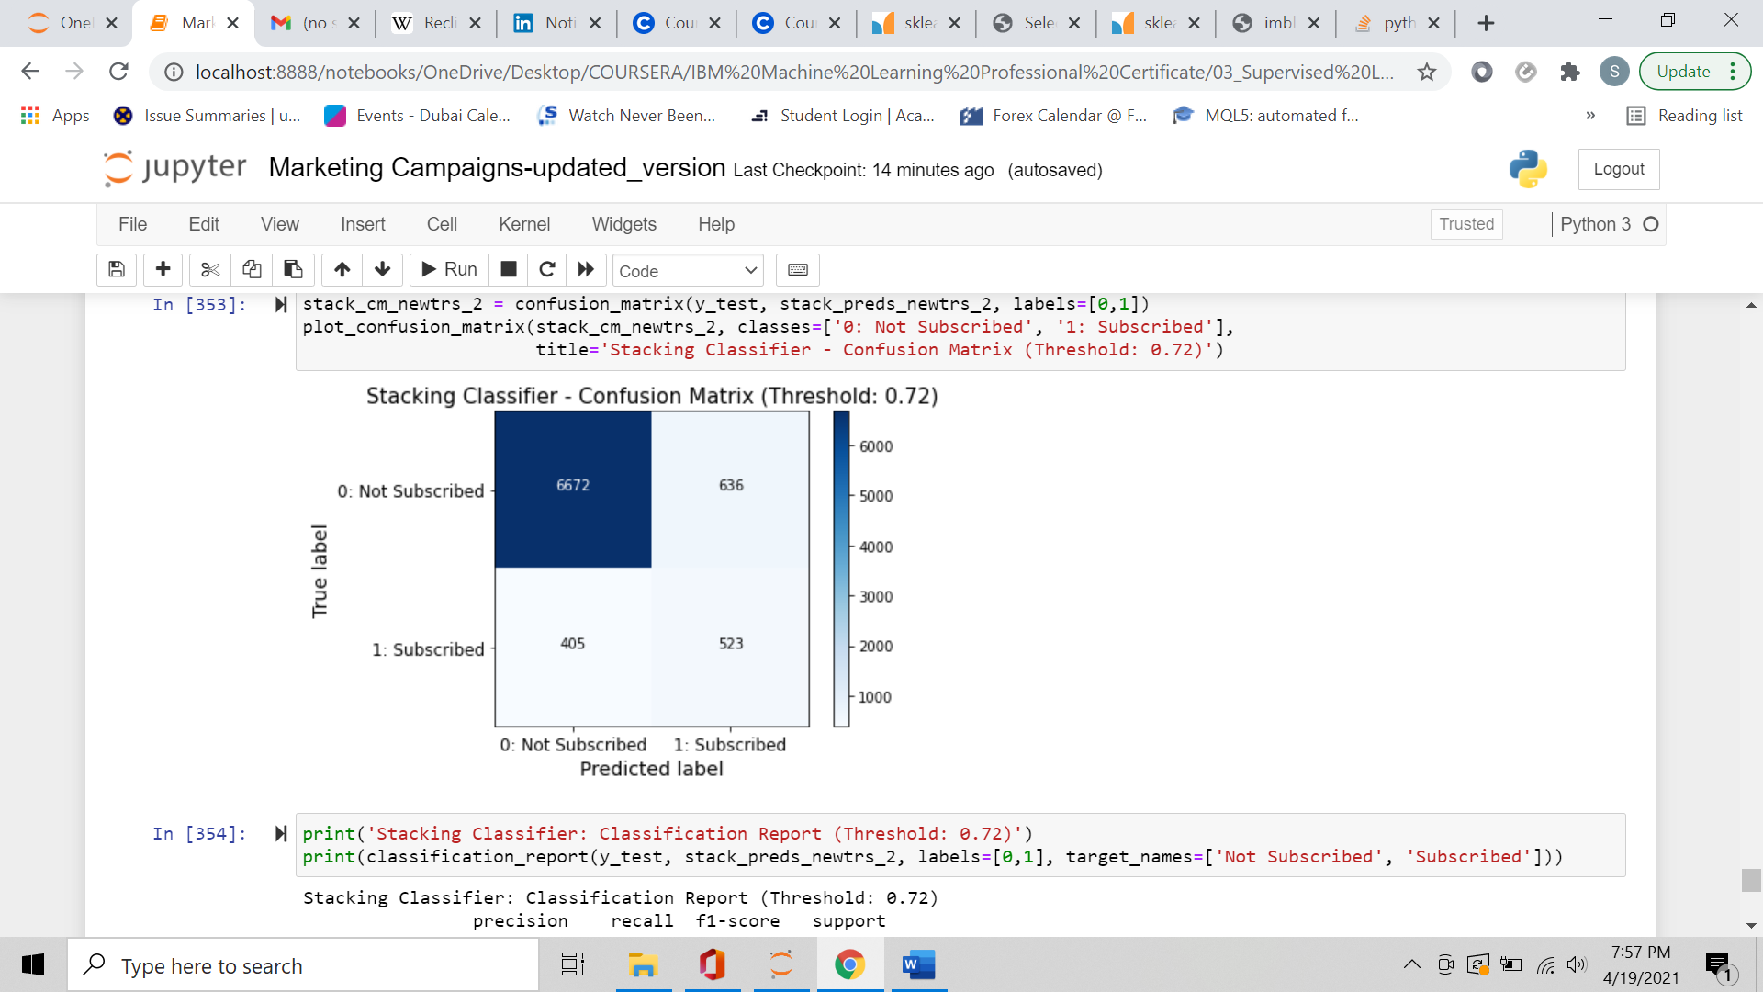

Stacking Classifier: Classification Report (Threshold: 0.72)

precision recall f1-score support

Not Subscribed 0.94 0.91 0.93 7308

Subscribed 0.45 0.56 0.50 928

accuracy 0.87 8236

macro avg 0.70 0.74 0.71 8236

weighted avg 0.89 0.87 0.88 8236

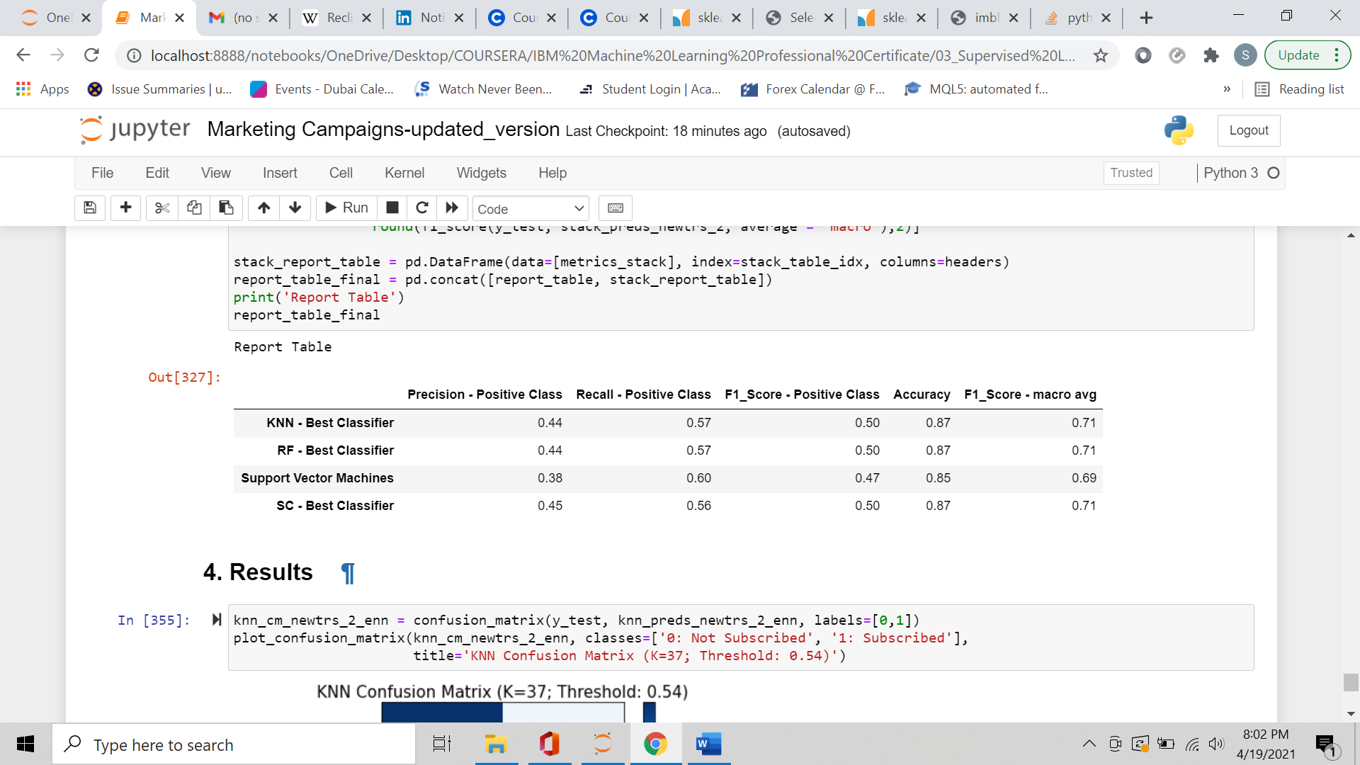Report Table:

K-Nearest Neighbors, Random Forest, and Stacking Classifier, optimized with best hyperparameters, class sampling, and best decision threshold, have very similar performances. Support Vector Machine is the classifier which performs the worst.

Best Stacking Classifier:

* Meta-Classifier: Logistic Regression.
  + Penalty: L2 penalty.
  + C - Regularization Parameter: 0.1.
  + Class weight: balanced weights.

### **3. Results.**

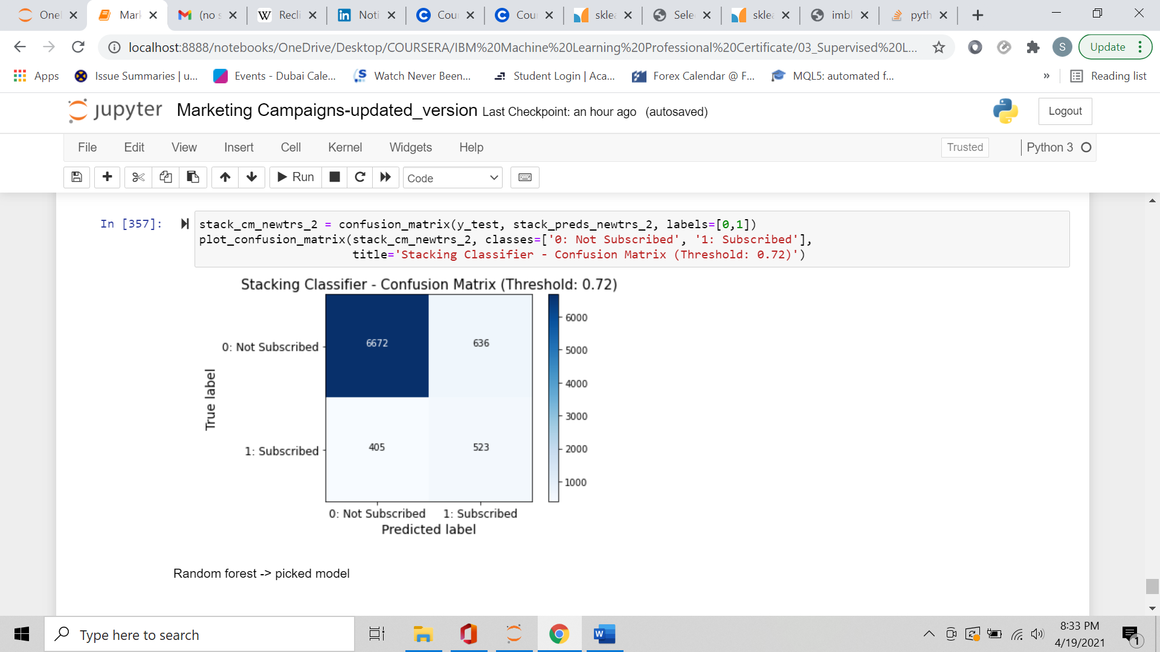

K-Nearest Neighbors, Random Forest, and Stacking Classifier were the best classifiers, with performance metrics very close to each other. Stacking Classifier, amongst the 3 models, had the greatest precision, but the lowest recall. From a marketing perspective, a marketing performance predictive model should predict as many correct successful examples (observations belonging to the positive class) as possible; therefore, considering the business priorities, KNN and Random Forest fitted the business purpose better.

KNN and Random Forest had almost identical out-of-sample performance metrics; although Random Forest slightly exceeds KNN performance by correctly predicting 2 more positive examples.

**I selected Random Forest as the classifier that best suited the project purpose,** optimized with the following hyperparameters:

* Number of estimators/trees: 10
* Criterion to measure the information gain: Gini
* Maximum depth of Decision Trees: 5
* Class Weight: balanced weights
* Probability Threshold: 0.63

1. **Discussion.**

Following the mentioned methodology (class sampling, decision threshold moving, performance benchmarking…), I managed to increase model F1-score (macro-average) from 0.65 (first KNN trained model) to 0.71 (Random Forest), measured on an out-of-sample set.

**Random Forest was the classifier that best suited the project purpose** (K-Nearest Neighbors, with Edited Nearest Neighbors undersampling technique, produced comparable results).

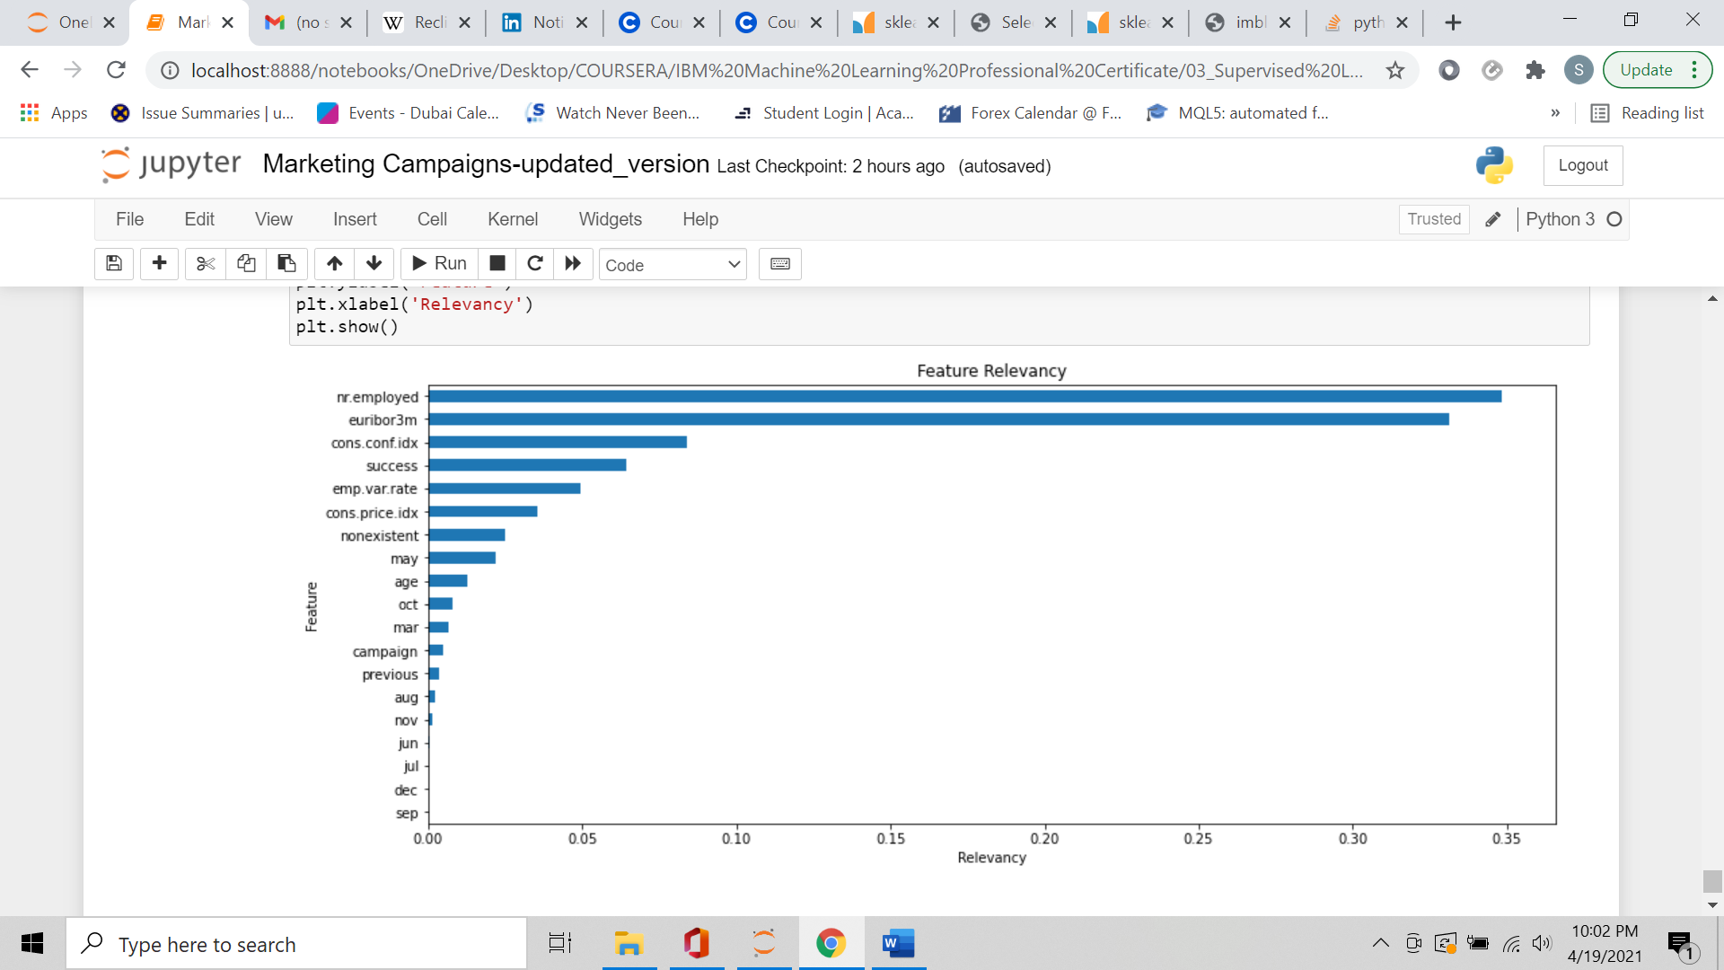Regarding the relevance of features, I looked into each feature importance with regard to target variable prediction:

The 5 most relevant features include 4 socio-economic variables, nr.employed (number of employees), euribor3m (euribor 3 month rate), cons.conf.idx (consumer confidence index), and emp.var.rate (employement variation rate), and 1 marketing-related variable (whether if the previous marketing campaign was successful or not).

nr.employed and euribor3m are the features with, by far, the greatest importance for predicting the success of the marketing campaign under consideration.

All other features have a relevancy score less than 0.05.

## **5. Conclusion.**

In this project I built a Classification model to predict whether an instance of a telemarketing campaign is successful or not. The main focus was on **prediction**, therefore my main purpose was to build a predictive model able to correctly predict as many positive example as possible, without losing too much accuracy.

A major problem was that the classes were quite imbalanced, so I had to consider following performance metrics (besides the Accuracy score):

* Precision, Recall, and F1-score for Positive Class
* Model F1-score (macro average)

I dealt with the imbalanced classes in 2 ways:

* Whereas available, I used the “class_weight” hyperparameter.
* If “class_weight” wasn’t available as model parameter, I applied below sampling approaches:
  + Undersampling the majority class with **Edited Nearest Neighbors**
  + Oversampling the minority class with **SMOTE (Synthetic Minority Oversampling Technique) algorithm**
  + Resampling the whole dataset combining **Edited Nearest Neighbors and SMOTE.**

To further improve classifier performance, I plotted ROC and Precision/Recall curves, check for the best decision threshold, and compared different model performances (which were indeed quite similar).

Quality of data was good: I found very few duplicates and wrongly recorded data, no missing values, and no outliers.

The selected model (Random Forest with probability threshold at 0.63) is able to correctly predict more than half of observations belonging to the positive class, with an overall accuracy of 87%. Therefore, the model’s performance can still improve, specially with regard to minority class predictions. For this purpose, **additional data is needed to train the model on a larger dataset, and capture the still-not-seen underlying relationships between variables.**

## **Appendix.**

*Reference Notebook Link - GitHub:*

[*https://github.com/SebastianoDenegri/classifier_marketing_campaign_success/blob/main/Marketing%20Campaigns-updated_version.ipynb*](https://github.com/SebastianoDenegri/classifier_marketing_campaign_success/blob/main/Marketing%20Campaigns-updated_version.ipynb)

*Decision Tree (bootstrap sample) from Random Forest - GitHub:*

[*https://raw.githubusercontent.com/SebastianoDenegri/classifier_marketing_campaign_success/main/decision_tree_from_rf.png*](https://raw.githubusercontent.com/SebastianoDenegri/classifier_marketing_campaign_success/main/decision_tree_from_rf.png)